b



Padification srs

Date: 2017-06-20

Version: 0.13.1

McKenzie College SWTS2102

1. Revision History

|  |  |  |  |
| --- | --- | --- | --- |
| Date | Author | Version | Revision Notes |
| 2017-06-06 | William Gale | 0.1 | Heading layout for document. |
| 2017-06-06 | Elie Godbout | 0.2 | Added Sections 2 and 3 being; Conformance and Normative references. |
| 2017-06-06 | Zachary Blue | 0.3 | Added Scope and Definitions, Abbreviations and Acronyms. |
| 2017-06-07 | William Gale | 0.4 | Integrated Player Concept into Section 5.1, Updated Revision History Layout, and Title Page. |
| 2017-06-07 | Elie Godbout | 0.5 | Integrated the Game Overview Concept in section 5.1. |
| 2017-06-07 | Kyle Gunton | 0.6 | Integrated section 5.1.3 Dungeons Overview Concept in section 5.1. |
| 2017-06-07 | Zachary Blue | 0.7 | Integrated the Mailbox Overview Concept in section 5.1. |
| 2017-06-07 | Ryan Breau | 0.8 | Integrated the Friend Overview Concept in section 5.1. |
| 2017-06-07 | Elie Godbout | 0.8.1 | Updates to section 5.1.1 (Game overview) Android device requirements updated to 4.0 and higher, egg machine section now explains what types of in-game currency are required to operate the specific types off egg machines. |
| 2017-06-07 | William Gale | 0.8.2 | Updated section 5.1.2 (Player Overview) Improved Definition of Rank, Removed Balloons from figure, Added descriptive location in definitions. |
| 2017-06-08 | Ryan Breau | 0.8.3 | Updated section 5.1.5 (Friends): Improved explanations, changed figures. Integrated section 5.1.6 (Game Currency). |
| 2017-06-08 | William Gale | 0.8.4 | Integrated (Monster) as section 5.1.3 and sub sections for Experience and Leveling, Base Stats, And Bonus Stats. Modified TOC to display 4 headings deep. |
| 2017-06-08 | Elie Godbout | 0.8.5 | Integrated sub-sections of Monster to section 5.1.3. Sub-sections: Assists, Rarity, Monster ID, Monster name, Monster box, Monster book and Selling monsters. Added image to title page. |
| 2017-06-08 | Zachary Blue | 0.8.6 | Added more information to the mail section describing the functions and areas more, moved the mail images to the right side of the page, integrated section 5.1.8 Egg Machines, updated structure |
| 2017-06-08 | Kyle Gunton | 0.8.7 | Integrated updates to section 5.1.4 (Dungeons): updated order of dungeons. Changed in-dungeon content to Dungeon Entrance, Dungeon Gameplay and Dungeon Completion.  Integrated Evolution, Power-Up/Fusion, Attributes, Types, And Skills sections to 5.1.3 (Monster) |
| 2017-06-08 | William Gale | 0.9.0 | Modified Revision History to have more room for Notes. Applied Cosmetic changes to title page, Re-arranged sub sections of Monster, and moved Monster box and Monster book to Player Section. |
| 2017-06-08 | Ryan Breau | 0.9.1 | Fixed issues with sections 5.1.6 and 5.1.7. |
| 2017-06-08 | Elie Godbout | 0.9.2 | Updated section 5.1.1 (Game Overview): Formatting, moved rewards to Dungeon Completion. Updated section 5.1.3 (Monster): Added a description for Monsters, new descriptions for Monster Number ID, Monster name and Rarity, and Clarified Monster Assists. |
| 2017-06-09 | Kyle Gunton | 0.9.3 | Updated section 5.1.4 (Dungeon): Formatting, simplified descriptions for Shop and Machine and section 5.1.3 (Monster): Formatting, moved Power-Up Fusion and Evolutions below Monster stats. |
| 2017-06-09 | William Gale | 0.9.4 | Integrated Section Navigation as section 5.1.2, |
| 2017-06-09 | Elie Godbout | 0.9.5 | Integrated Multiplayer Mode in Section 5.1.8 (Dungeons) as section 5.1.8.9 |
| 2017-06-09 | Kyle Gunton | 0.9.6 | Integrated Teams in Section 5.1.4 (Monsters) as section 5.1.4.12  Moved Team Status from friends to teams |
| 2017-06-09 | Ryan Breau | 0.9.7 | Integrated Section 5.1.9 Shops. |
| 2017-06-09 | Zachary Blue | 0.9.8 | Integrated Section 5.1.6 Quests, changed egg machine description to be more detailed, changed Mail to Mail System |
| 2017-06-11 | William Gale | 0.10.0 | Fixed Header alignment on revision Table, Broke Navigation Sub Sections into the appropriate sections, Trimmed information on Navigation UMLs and changed to Horizontal. Moved all images into margins to stop cut-off. |
| 2017-06-11 | William Gale | 0.10.1 | Integrated Processes “Power-Up Fusion” and “Evolution” into Section 6.1, Moved “Selling Monsters” into 6.1 |
| 2017-06-12 | Ryan Breau | 0.10.2 | Fixed issues found in sections 5.1.8 and 5.1.9. |
| 2017-06-12 | Elie Godbout | 0.10.3 | Updated section 5.1.4.10 (Multiplayer Mode), section 5.1.2 (Player -Monster Box) and Added Assists to section 6 as 6.1.4. |
| 2017-06-12 | Ryan Breau | 0.10.4 | Integrated section 6.1.5. |
| 2017-06-12 | Kyle Gunton | 0.10.5 | Updated lists of attributes, types, and skills in monster. Integrated section 6.1.6 (Dungeon Gameplay) |
| 2017-06-12 | Zachary Blue | 0.10.6 | Integrated Navigation as a process in section 6.1 |
| 2017-06-12 | Elie Godbout | 0.11.0 | Updated the following sections: 5.1.1 (Game overview), 5.1.3.11 (Assist), 5.1.4.10 (Multiplayer Mode), 6.1.2 (selling Monsters) & 6.1.5 (Assists). |
| 2017-06-12 | Zachary Blue | 0.11.1 | Integrated and updated sections 5.1.5(Quests), 5.1.6(Mail System), and 5.1.10(Egg Machines) clarifying information and removing absolute values. |
| 2017-06-13 | William Gale | 0.11.2 | Modified Player Section, Modified Power-Up Fusion Process Section, Reformatted Definition Section. |
| 2017-06-13 | Zachary Blue | 0.11.3 | Updated section 6.1.1(Navigation) to have a description at the beginning and gave more detail into how to get to the different important areas of the game. |
| 2017-06-13 | Ryan Breau | 0.11.4 | Modified Sections 5.1.7, 5.1.8, 5.1.9, and 6.1.6. |
| 2017-06-13 | Kyle Gunton | 0.11.5 | Added Table of Tables. Changed some figure captions to table captions. Updated Types, Skills, Team, Dungeons in concepts and Dungeons Gameplay in processes. |
| 2017-06-13 | Kyle Gunton | 0.11.6 | Updated Dungeon Completion Section |
| 2017-06-13 | Elie Godbout | 0.12.0 | Updated sections; 5.1.1 (Game overview), 5.1.3 (Monster, Monster identification & Assist), 6.1.2 (Selling a Monster) and 6.1.7 (Dungeon Gameplay & multiplayer). |
| 2017-06-13 | William Gale | 0.12.1 | Reworked Section 1 (Scope), Reworked Section 5.1.6 (Mail System), Reworked Section 6.1.4 (Evolution), Fixed spelling and grammar in various sections. |
| 2017-06-14 | Ryan Breau | 0.12.2 | Updated sections 5.1.7, 5.1.8, 5.1.9, and 6.1.6. Fixed issue regarding revision 0.11.3. |
| 2017-06-14 | Zachary Blue | 0.12.3 | Updated Sections 5.1.5(Quests), 5.1.10(Egg Machines), and 6.1.1(Navigation) |
| 2017-06-14 | Kyle Gunton | 0.12.4 | Integrated section 6.1.2 Player Process. Updated Monster, Dungeons and Dungeon Gameplay. Formatted Tables. |
| 2017-06-14 | Ryan Breau | 0.12.5 | Moved section 5.1.1 (Now section 5.2.1) to section 5.2. |
| 2017-06-15 | William Gale | 0.12.6 | Updated Scope Section, Evolution Section, formatted all full size images to 5cm, Modified Layout of various sections to reduce whitespace, Added headings for future sections. |
| 2017-06-15 | William Gale | 0.12.7 | Integrated Application Social Concepts and Process Sections, Added Tagging to in-scope. |
| 2017-06-16 | Ryan Breau | 0.12.8 | Integrated Application Team concepts and process sections. |
| 2017-06-16 | Elie Godbout | 0.12.9 | Integrated PADification product concept for monsters. |
| 2017-06-16 | Zachary Blue | 0.12.10 | Integrated PADification product concept and process for Account. |
| 2017-06-16 | Kyle Gunton | 0.12.11 | Integrated PADification product concept and process for Collection. |
| 2017-06-16 | Elie Godbout | 0.12.12 | Integrated PADification product processes for monsters. (section 6) |
| 2017-06-16 | Ryan Breau | 0.12.13 | Integrated Application Overview into section 5.2.2. |
| 2017-06-16 | Zachary Blue | 0.12.14 | Added the Author Game Information table which displays the names, usernames, and player IDs for all the authors of PADification |
| 2017-06-20 | Ryan Breau | 0.13.0 | Updated sections 5.2.1.7 (Now 5.2.1.6), 5.2.1.8, 6.1.1.7, and 6.1.2.4. |
| 2017-06-20 | Zachary Blue | 0.13.1 | Updated Sections 5.2.1.5, 5.2.1.6 (Now 5.2.1.7), 5.2.1.9, 5.2.2.2, 6.1.1.1, and 6.1.2.1 |

1. Table of Contents

I. Revision History 2

II. Table of Contents 5

III. List of Figures 7

IV. Table of Tables 9

1 Scope 10

1.1 In Scope 10

1.2 Out of Scope 11

2 Conformance 12

2.1 Intended usage 12

2.2 Conformance to Processes 12

2.3 Conformance to information item content 12

3 Normative References 12

4 Terms, Definitions, and Abbreviated Terms 13

4.1 Terms and Definitions 13

4.2 Acronyms and Abbreviations 14

5 Concepts 16

5.1 Introduction 16

5.2 Requirements Fundamentals 16

5.2.1 Game Concepts 16

5.2.1.1 Game overview 16

5.2.1.2 Player 18

5.2.1.3 Monster 20

5.2.1.4 Dungeons 28

5.2.1.5 Quests 30

5.2.1.6 Friends 31

5.2.1.7 Mail System 33

5.2.1.8 Shops 34

5.2.1.9 Egg Machines 36

5.2.2 Application Concepts 38

5.2.2.1 Application Overview 38

5.2.2.2 Account 38

5.2.2.3 Monster 38

5.2.2.4 Collection 39

5.2.2.5 Team 40

5.2.2.6 Social 40

5.3 Practical Considerations 41

5.4 Requirement Information Items 41

6 Processes 42

6.1 Requirements Processes 42

6.1.1 Game Processes 42

6.1.1.1 Navigation 42

6.1.1.2 Player Process 42

6.1.1.3 Selling Monsters 43

6.1.1.4 Power-Up Fusion 44

6.1.1.5 Evolution 45

6.1.1.6 Assists 46

6.1.1.7 Edit Team 47

6.1.1.8 Dungeon Gameplay 49

6.1.2 Application Process 53

6.1.2.1 Account 53

6.1.2.2 Monster 53

6.1.2.3 Collection 54

6.1.2.4 Team 55

6.1.2.5 Social 55

6.2 Stakeholder Requirements Definition Process 57

6.3 Requirements Analysis Process 57

6.4 Requirements Engineering Activities in Other Technical Process 57

6.5 Requirements Management 57

7 Information Items 57

8 Guidelines for Information Items 57

9 Information Item Content 57

1. List of Figures

Figure 5.2‑1: Game Menu Navigation 16

Figure 5.2‑2: Player Information 16

Figure 5.2‑3: Menu Bar 16

Figure 5.2‑4: Player ID search 17

Figure 5.2‑5: Information Banner and Player ID 18

Figure 5.2‑6: Monster box 19

Figure 5.2‑7: Selecting Starting Monster 19

Figure 5.2‑8: Monster Card 21

Figure 5.2‑9: Monster Assist 21

Figure 5.2‑10: Leader Skill & Active Skill 22

Figure 5.2‑11: Chart of Experience Curves 23

Figure 5.2‑12: Power-Up Fusion 24

Figure 5.2‑13: Evo Tree 24

Figure 5.2‑14: Evolution 25

Figure 5.2‑15: Monster info 26

Figure 5.2‑16: Edit Team 26

Figure 5.2‑17: Awoken Badge 27

Figure 5.2‑18: Dungeons & Sub-Dungeons 28

Figure 5.2‑19: Dungeon Entrance 28

Figure 5.2‑20: Special Dungeon Menu 29

Figure 5.2‑21: Multiplayer Modes 30

Figure 5.2‑22: Quest Screen 30

Figure 5.2‑27: Friend Menu Navigation 31

Figure 5.2‑28: Select a Helper Screen 31

Figure 5.2‑29: Friend List 32

Figure 5.2‑30: Friend Options 32

Figure 5.2‑23: Mail Navigation 33

Figure 5.2‑24: Mail Expiry 33

Figure 5.2‑25: Sort / Delete 33

Figure 5.2‑26: Mail Screen 33

Figure 5.2‑32: Shop Menu 34

Figure 5.2‑31: Shop Navigation 34

Figure 5.2‑33: Magic Stone Shop 34

Figure 5.2‑34: Purchase Monster 34

Figure 5.2‑35: Purchase Dungeons with Coins 35

Figure 5.2‑36: Restore Stamina 35

Figure 5.2‑37: Increase Max No. of Friends 35

Figure 5.2‑38: Increase Capacity 35

Figure 5.2‑39: Machine Menu Navigation 36

Figure 6.1‑1: Account Creation Process 42

Figure 6.1‑2: Logging In 42

Figure 6.1‑3: Rank Up 43

Figure 6.1‑4: Change Player Name 43

Figure 6.1‑5: Latent Skill Replacement 44

Figure 6.1‑8: Evo Fusion 45

Figure 6.1‑8: Ultimate Evolution 45

Figure 6.1‑8: Reincarnation 45

Figure 6.1‑9: Editing Subs 47

Figure 6.1‑10: Editing Leader 47

Figure 6.1‑11: Select at Once 47

Figure 6.1‑12: Changing Awoken Badge 47

Figure 6.1‑13: Edit Team Screen 48

Figure 6.1‑14: Editing Team Name 48

Figure 6.1‑15: Dungeon Gameplay Process 49

Figure 6.1‑16: Two Player Turn System 49

Figure 6.1‑17: Three Player Turn System 50

Figure 6.1‑18: Input Room ID 50

Figure 6.1‑19: Dungeon Menu for 3-Player Mode 51

Figure 6.1‑20: Created Room 52

1. Table of Tables

Table 1: Attributes 20

Table 2: Types 20

Table 3: Awoken Skills 22

Table 4: Latent Awoken Skills 23

Table 5: Team Stats 26

Table 6: Awoken Badges 27

Table 7: Team Symbols 27

Table 8: Py Chart 43

# Scope

PADification will allow a Player to create an account represented by their Puzzles and Dragons Player ID. With an Account, the Player will then be able to Create, Update, and Delete Monsters Cards to represent Monsters Cards with-in Puzzles and Dragons. With the Created Monster Cards, The Player will be able to Create, Update, and Delete Teams. A Team will display the stats calculated as in Puzzles and Dragons allowing a Player to plan Team Compositions. The Player will be able to View the Monster Cards and Teams created by other Players that use PADification, and rate those teams for quality and utility.

## In Scope

|  |  |
| --- | --- |
| *Monster Cards* | * Stats, for all Monster Cards available in North America, will be viewable as if Max Level with no modifiers. * The “Evolution Path” for Monster Cards will be Viewable. * The Number of “Awoken Skills” Awoken will be modifiable. * “Latent Awoken Skills” will be assignable to Monster Cards as in Puzzles and Dragons. * “Assistants” will be able to be assignable to Monster Cards. * “Plus Stats” will be adjustable for each Stat individually. * Stats, of Monster Cards created by the Player, will be viewable with Modifiers from “Awoken Skills”, “Latent Awoken Skills”, “Assistants”, and “Plus Stats” * Skill Level can be set. * Monster Point Value of Monster Cards * Monster Role Tags |
| *Teams* | * Monster Cards can be assigned to Monsters. * Teams will be nameable. * Teams Stats will be calculated accurately using the Stats of all Monster Cards Assigned. * Resistances will be displayed with Team information. * Orb drop chance increases will be displayed with Team information. * Move time of team will be displayed with Team information. * Leader Skill information will be displayed with Team information. |
| *Collection* | * Creating Monster Card Instance. * Updating Monster Card Instance. * Deleting Monster Card Instance. * Tracking Life of Monster Card Instance. * Sorting Monster Card Instances. * Filtering Monster Card Instances. |
| *Account* | * Account Creation * Account Update (“Password”, “E-mail”) * Account Logical Deletion * Account Login Authentication |
| *Wish-List* | * Adding Monster Cards * Removing Monster Cards * Migrate Monster Card to Collection |
| *Social* | * View User Teams / Monster Card Collection / Wish list * Follow Users * Team Rating System * Team submission with informative tags |

## Out of Scope

|  |  |
| --- | --- |
| *Monster Cards* | * Monster Series * Coin Value * Experience Value * Monster Locations |
| *Teams* | * Leader Skill Modifiers * Team Symbols |
| *Account* | * Changing Player ID * Changing User Name * Player Experience, Rank, Stamina, Currencies * Dungeon Progression * Quest Progression |
| *Wish-List* | * Multiple Wish Lists * Wishlist Import * Wishlist Export |
| *Collection* | * Collection Export * Collection Import |
| *Social* | * Friends * Messaging |

# Conformance

## Intended usage

The intention of conformance for this SRS document is to help stakeholders understand where the data and information the group has gathered come from and under what format, scope and decree they will follow.

## Conformance to Processes

* The PADification final product aims simulate processes found in the Puzzles and dragons mobile video-game developed by Gung-Ho online entertainment Inc. The main process is as follows:
  + Creation, updates and deletion of teams
    - Leader monster
    - Sub monsters
    - Team name
    - Badge equipped
* The idea behind this is to allow players of puzzles and dragons from around the world to share the teams as well as monsters they own to other players. Something that puzzles and dragons does not permit at the current time.

## Conformance to information item content

* The PADification final product gathers all its information from the puzzles and dragons mobile video-game developed by Gung-Ho online entertainment Inc. as well as from reputable third-party websites.
* If information found within third-party resources should ever prove unreliable, unsure and/or faulty, it is required to have the issue resolved by identifying it within official resources.
* Information regarding instances of player information and instances of specific monsters are found within puzzles and dragons by way of the player’s account information.

# Normative References

Official Gung-Ho References

* <http://www.gunghonline.com/>
* <http://puzzleanddragons.us/>
* <https://www.facebook.com/PuzzleAndDragonsOfficial/>
* <https://twitter.com/PuzzDragNA>
* <https://itunes.apple.com/ca/app/puzzle-dragons-english/id563474464?mt=8>
* <https://play.google.com/store/apps/details?id=jp.gungho.padEN&hl=en>

Third Party Resources

* <http://www.puzzledragonx.com/>
* <https://mantasticpad.com/>
* <http://pad.wikia.com/>

ISO/IEC/IEEE 29148-2011 SRS International Standard Document

* <http://ieeexplore.ieee.org/document/6146379/>

# Terms, Definitions, and Abbreviated Terms

## Terms and Definitions

***+ (Plus) stats*** Bonus stats applied to HP, ATK, and RCV. Up to 99 + stats can be granted to each stat for a monster for a total of 297. A bonus of +# times 10 is granted to HP, +# times 5 for ATK, and +# times 3 for RCV.

***Active Skill*** An modifier belonging to monsters that can be used in dungeons to modify the board, the player’s team or the enemies.

***Assist Monsters*** Monsters can be assigned to other monsters. The assisted monster gains the active skill of the assisting monster as well as a possible stat boost while the assisting monster can no longer be brought into dungeons or sold. Not all monsters can be assists.

***Attack*** A monster’s statistic that determines the base amount of damage a monster can deal.

***Attribute*** A property of a monster that determines the type of damage a monster will deal. A monster can currently have up to two (minimum of one) of five attributes consisting of Fire, Water, Wood, Light, and Dark.

***Awoken Skill*** A passive modifier granted to a monster.

***Awoken Skills*** A passive modifier a monster may have. All monsters with the same Monster ID have the same Awoken Skills. A monster may have zero to nine of them.

***Database*** A structured set of data held in a computer, especially one that is accessible in various ways.

***Dungeon*** A section within PAD that allows the user to obtain experience, coins, magic stones, and monsters.

***Egg machine*** A feature that allows a user to use magic stones or pal points to procure a random monster from a pool of monsters.

***Evolution*** Monsters can evolve/devolve into other monsters when certain conditions are met.

***Health Points*** A monster’s statistic that determines how much damage a monster can take before a player dies.

***Latent Awoken Skills*** A type of awoken skill that you assign to a monster.

***Latent Skill*** A passive modifier that can be assigned to monsters through power-up/fusion. Up to a max of 6 can be added to a single monster.

***Leader Skill*** An in-dungeon modifier granted to the player based on the leader monster. Not all monsters have one.

***Magic Stones*** A in-game currency within that can be used to restoring stamina, buying eggs from the egg machine, and allowing the user to continue a dungeon upon death (where applicable). Purchasable with real money.

***Mail System*** An in-game communications system through which players can communicate with other players and admin. Monsters and currency are able to be obtained through the mail system.

***Monster*** Characters that can be obtained within the game through dungeons, mail, and egg machines.

***Monster Assist*** A monster assigned to another monster to offer a second active skill and slight stat boost.

***Monster Experience*** An indicator of a monster’s current progression towards it’s maximum potential.

***Monster ID*** All unique integer identifier assigned to each monster.

***Monster Level*** A statistic of a monster that acts as a modifier based on a monster’s experience.

***Monster Name*** All monsters have a name that are unique (if only by case).

***Monster Types*** Monsters have 1-3 types. There are currently 12 different types a monster may have.

***Pal points*** An in-game currency collected from helping friends in dungeons, using friends’ monsters in dungeons, and logging in each day that is used to purchase pulls from the Pal Egg machine.

***Puzzle and Dragons*** A game involving monster collection and team creation required to defeat more difficult Dungeons.

***Rank*** A player grading system that determines the amount of stamina, friends, features the Player can have.

***Rarity*** An indicator of how common or uncommon a monster is.

***Recovery*** A monster’s statistic that determines the base amount of health a monster will heal for the team.

***Stamina*** An integer value that determines a player’s access to a dungeon. Entering a dungeon will take a specified amount of stamina from the player’s current stamina count. Stamina recharges over time up or upon ranking up, to the maximum amount a player can hold. The amount a player can hold is based on rank.

***Type*** A classification of a monster. A monster can currently have up to three (minimum of one) of (currently) twelve types.

* 1. Acronyms and Abbreviations

***PAD*** Puzzles and Dragons

***HP*** Health Points

***ATK*** Attack

***RCV*** Recovery

***RDBMS*** Remote Database Management service

***DB*** Database

***NA*** North America

# Concepts

## Introduction

## Requirements Fundamentals

### Game Concepts

#### Game overview

Puzzles and Dragons is a video-game developed by Gung-Ho entertainment Inc. for mobile platforms. The objective of Puzzles and Dragons is to collect monsters, create teams with these monsters in order to complete dungeons which grants the player with various rewards such as new monsters and in-game currency. Clearing dungeons also pushes a player’s account by way of experience points. This effectively increases a player’s ability to progress and gain access to more features of the video-game.



Figure 5.2‑1: Game Menu Navigation

Compatible mobile devices:

* Apple IOS 6.0 and higher
* Android 4.0 and higher
* Kindle
  + Fire (2nd generation)
  + Kindle HP
  + Kindle Fire HDX

##### Player account



Figure 5.2‑2: Player Information

Puzzles and Dragons requires the player to create an account in order to use the application. A player’s account will contain the player’s personal information and account information such as currency, rank, monsters, cleared dungeons, etc.

##### Game Navigation



Figure 5.2‑3: Menu Bar

Puzzles and Dragons uses a Simple Category Style Navigation breaking up Into Individual Subjects. Starting the Game Brings you to the Title Screen which allows you to start the game or access Data Restoration. Once inside the game the categories are listed at the bottom excluding News and Quest, which are located in the top right of the screen. The Menu Bar is accessible through the game, except while in a dungeon, Pulling and Egg machine, or Composing a Message.

##### Monster

Monsters collectible characters usable for combat against other monsters in Puzzles and Dragons.

##### Dungeons

Dungeons is where the gameplay of Puzzles and Dragons is found. Here, the player will be put to the test against monsters in a puzzle based combat environment.

##### Shop

From the Shop option, players have access to shops in Puzzles and Dragons. Here, a player can spend the in-game currency they’ve acquired to purchase in-game goods or enhance their account. A player may also purchase in-game currency by using funds from their real-life banking accounts or Credit cards. These are called Microtransactions.

##### Machine

From the machine option, a player has access to a lottery style monster generator known in-game as egg machines. These allow players to spend in-game currency to obtain randomly selected monsters.

##### Friend

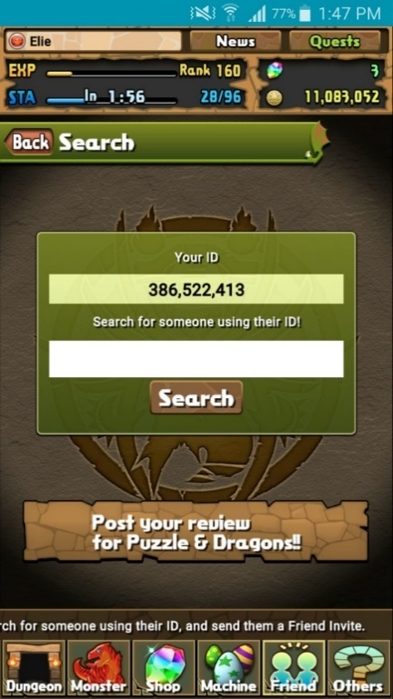

Figure 5.2‑4: Player ID search

From the Friend option, players may interact with other players by sending invitations to others and register them as friends by sharing player IDs. Players can then choose to send messages to their friends and best friends.

##### Other

From the Others option, players have access to a wide range of options concerning the functions of the application, links to external sources, services about the game, information about Gung-Ho, options to change certain settings, etc.

##### Quests

Found on the top right corner, players have access to quests. These offer rewards to players once specific conditions are met. Each quest is classified within categories and state the specific request needed to obtain the reward associated to a given quest.

##### News

On the top corner of the window, next to the quests option, players have access to a news section to view the latest information on the daily activities of Puzzles and Dragons and/or any changes and updates done to the application. All these are composed by Gung-Ho.

#### Player



Figure 5.2‑5: Information Banner and Player ID

The representation of the entity playing Puzzles and Dragons, it holds all information related to the specific user, it consists of the following Elements:

|  |  |
| --- | --- |
| Author | Player ID |
| Elie Godbout | 386,522,413 |
| Kyle Gunton | 355,320,414 |
| Judson Murray | 369,404,367 |
| Ryan Breau | 350,520,414 |
| William Gale | 308,681,384 |
| Zachary Blue | 352,322,418 |

Table : Author Game Information

##### Player Identification

Players are uniquely Identified with the Player ID. Located at the top left corner of the start screen, it is comprised of 9 digits generated automatically and is unique among all players worldwide.

Players can also be identified with a Player Name, located at the top left corner of the information banner, this is chosen by the player and is not unique, it is mainly a cosmetic feature.

##### Player Ranking

Players allocate Experience during gameplay by completing dungeons, displayed in the information banner as a “EXP”. Allocating the preallotted amount of Experience will increase a Players Rank.

A Player’s Rank is used to determine the game content accessible by the player, as well as increasing the Max Team Cost, Max Stamina, Max Friends, and the number of Teams a Player has. These increases are predetermined by rank. Increasing rank will also refill your Stamina.

##### Player Stamina

The Players Stamina is used to enter a dungeon. It is located in the information banner as “STA” on the bottom left. Stamina Regenerates at a rate of 1 per 3 mins, but will not regenerate more than the Maximum Stamina. Stamina can be purchased via a Magic Stone which will grant you an amount of Stamina equal to your Maximum Stamina, adding it to your current stamina; It can exceed your Maximum Stamina as Excess Stamina.

##### Player Currencies

Currencies are acquired through dungeon completion, selling of monster, playing with friends and helpers, rewards, and with microtransactions. There are several types of currencies including Coins, Magic Stones, Pal Points, and Monster Points. Your Coins and Magic stones are displayed in the top right of the information banner. Pal points are displayed at the Pal Egg Machine and Monster Points are displayed on the Monster Point Store Button in Shop. All currencies can be accumulated through normal play of the game, but a player can purchase Magic Stones if they so desired.

##### Player Monster Collection

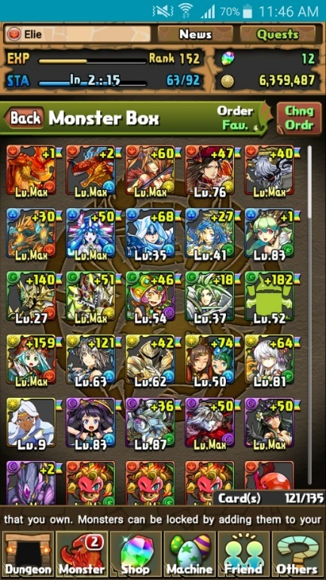

Figure 5.2‑6: Monster box

Players collect Monster Cards that are stored in the Players “Monster Box”. The amount of Monster Cards a Player can store, are listed in the bottom right corner of the “Monster Box”. The amount increases when specific Ranks are reached, but can also be increase via the “Increase Capacity” using a magic stone. Players are able to obtain and hold more monsters than the maximum capacity. This will prevent the user to use certain features until the contents of the monster box is returned to a lower value than the maximum capacity.

Players can create Teams of Monster Cards. Each team is comprised of 1-5 Monster Cards, but must have a total Team Cost less or equal to the Max Team Cost a Player has. Each Team can be equipped a Badge once the Player has completed their first quest.

Monster Cards collected and Monsters encountered in dungeons are added to the players “Monster Book”. All Monster IDs are listed with Question Mark Icons, Once Encountered in a dungeon the Monster Cards Thumbnail is displayed slightly transparent, if the Monster Card is collected the thumbnail is Opaque.

##### Player Friends

Players can invite another Player to be their friend after using one of their Monsters as a Helper, or inviting them directly by searching for their Player ID. Having a Player as a friend frequently lists their Monsters as Helpers.

##### Player Attribute



Figure 5.2‑7: Selecting Starting Monster

The Player is presented with a mandatory tutorial the first time opening Puzzles and Dragons. During the tutorial, the Player picks one of three monsters “Tyrra - Fire”, “Plessie - Water”, or “Brachy - Wood”. The attribute of the monster picked will be the Player Attribute. It is displayed to the left of the player name in the information banner.

#### Monster

Monsters are collectible characters found in Puzzles and Dragons. They serve as a player’s protagonists as well as the antagonists. Each monster is defined by numerable properties, some are commonly shared among all monsters while others are unique to specific monsters. By collecting, enhancing and evolving monsters, players increase their chances of survival when confronting the monsters found in dungeons. Monsters can also be referred to as Monster Cards.

##### Monster Identification

Each monster can be uniquely identified by a number known as their Monster Number ID and by their Name.

##### Rarity

Each monster has a value represented by stars. This helps players determines how valuable a monster can be and how common it may be.

##### Attribute

Attributes are the property of a monster that determines the type of damage a monster will deal in a dungeon. A monster can currently have up to two (minimum of one) of five attributes consisting of:

|  |  |  |  |  |  |  |  |  |  |  |
| --- | --- | --- | --- | --- | --- | --- | --- | --- | --- | --- |
| http://www.puzzledragonx.com/en/img/allow/1.png | Fire | http://www.puzzledragonx.com/en/img/allow/2.png | Water | http://www.puzzledragonx.com/en/img/allow/3.png | Wood | http://www.puzzledragonx.com/en/img/allow/4.png | Light | http://www.puzzledragonx.com/en/img/allow/5.png | Dark |  |

Table 1: Attributes

##### Types

A classification of a monster. A monster has a minimum of one type.

|  |  |  |  |  |  |
| --- | --- | --- | --- | --- | --- |
| http://www.puzzledragonx.com/en/img/type/6.png | God | http://www.puzzledragonx.com/en/img/type/5.png | Attacker | http://www.puzzledragonx.com/en/img/type/1.png | Dragon |
| http://www.puzzledragonx.com/en/img/type/9.png | Devil | http://www.puzzledragonx.com/en/img/type/2.png | Balanced | http://www.puzzledragonx.com/en/img/type/3.png | Physical |
| http://www.puzzledragonx.com/en/img/type/12.png | Machine | http://www.puzzledragonx.com/en/img/type/7.png | Evo Material | http://www.puzzledragonx.com/en/img/type/11.png | Awaken Material |
| http://www.puzzledragonx.com/en/img/type/4.png | Healer | http://www.puzzledragonx.com/en/img/type/8.png | Enhance Material | http://www.puzzledragonx.com/en/img/type/13.png | Redeemable Material |

Table 2: Types

##### Monster Stats

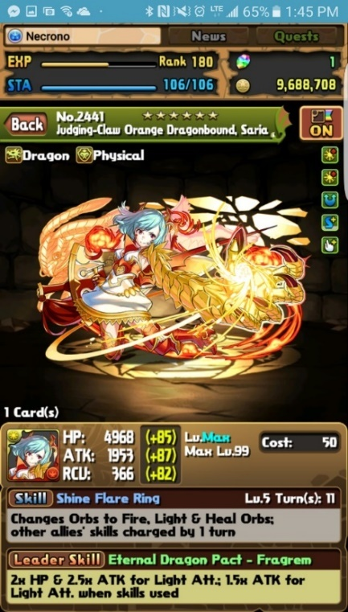

Figure 5.2‑8: Monster Card

Each Monster has Stats for:

* Health Points (HP) – The Amount of Health a Monster will add to a Team.
* Attack (ATK) – The Amount Attack power that will be used with Attributes to calculate Team ATK.
* Recovery (RCV) – The Amount of Recovery that will be added to a Team, used for Healing Health Points.

Each Stat is given a Minimum Value and Maximum Value, and also a Growth Rate; There are 3 different Growth Rates used:

* Early Bloomer – Stats are increased quicker at early levels and give less gain as the monster approaches Maximum Level.
* Normal – Each level increases the Stat value by the same amount.
* Late Bloomer – Stats are increased slowly at early levels but increase gain as the monster approaches Maximum Level.

###### Monster Bonus Stats

In Addition to the Base Stat values the total stats of the monster can be increased in 4 different ways:

* Plus (+) Stats – Plus Stats are permanently added to a Monster through Power-Up fusion with Monsters who have Plus Stats, increasing only the Plus Stats on Matching Stats. They are color coded Yellow in the Monster Information Section. Each Stat can have a total of 99 Plus Stats for a Grand total of 297. The Gains of Plus Stats are different for each Stat:
  + - HP Gains 10 HP for Each Plus Stat for a total of 990
    - ATK Gains 5 ATK for Each Plus Stat for a total of 495
    - RCV Gains 3 RCV for Each Plus Stat for a total of 297
* Assist Bonus – Color coded Blue in the Monster Information Section, having a monster assistant equipped of the same Primary Element will grant bonus Stats of:

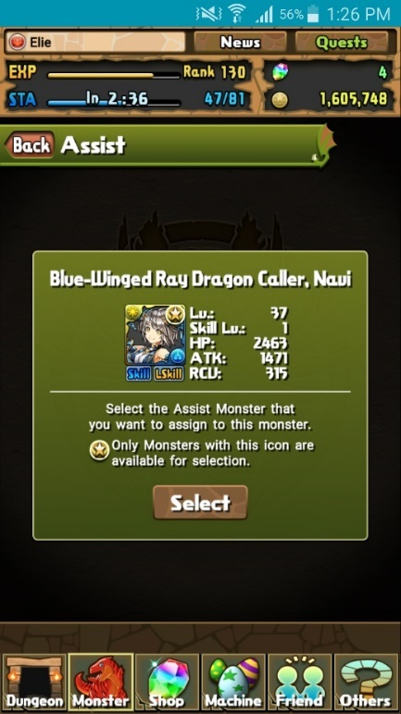

Figure 5.2‑9: Monster Assist

* + - HP – Will be granted 10% of the monster assistants Base HP
    - ATK – Will be granted 5% of the monster assistants Base ATK
    - RCV – Will be granted 15% of the monster assistants Base RCV
* Awoken Skills – Some Awoken Skills have the effect of increasing base stats a small percentage or set amount.
* Latent Awoken Skills – Some Latent Awoken Skills have the effect of increasing base stats a small percentage or set amount.

##### Skills

###### Skill

Figure 5.2‑10: Leader Skill & Active Skill



A modifier belonging to monsters that can be used in dungeons to modify the board, the player’s team or the enemies. Active skills are used within dungeons by the player. They have three main pieces to them. The effect, the level of the skill, and its cooldown.

* The effect is a modifier that may change the board, the players monsters, or the enemy monsters.
* The level is the current level the skill is at. Leveling up a skill will reduce its cooldown by one turn. Skills have a maximum level.
* The cooldown is the number of turns a player must take within a dungeon before they are able to use the active skill.

###### Leader Skill

A passive in-dungeon modifier granted to the player based on the leader monster. This may modify the board, the player’s team or the enemies. Also, upon meeting certain requirements, additional bonuses will be added during dungeon play. Not all monsters have a leader skill. Effects from multiple leader skills multiply.

|  |  |  |  |  |  |
| --- | --- | --- | --- | --- | --- |
|  | Attacker Killer | Enhanced HP | Enhanced HP |  | Physical Killer |
| Auto-Recover | Auto-Recover |  | Enhanced Light Att. | Recover Bind | Recover Bind |
|  | Awaken Material Killer |  | Enhanced Light Orbs |  | Redeemable Material Killer |
|  | Balanced Killer |  | Enhanced Water Att. |  | Reduce Dark Damage |
|  | Devil Killer |  | Enhanced Water Orbs |  | Reduce Fire Damage |
|  | Dragon Killer |  | Enhanced Wood Att. |  | Reduce Light Damage |
|  | Enhance Material Killer |  | Enhanced Wood Orbs |  | Reduce Water Damage |
| Enhanced Attack | Enhanced Attack |  | Evo Material Killer |  | Reduce Wood Damage |
|  | Enhanced Combo | Extend Time | Extend Time |  | Resistance-Bind |
|  | Enhanced Dark Att. | http://www.puzzledragonx.com/en/img/awoken/47.png | Follow-Up Attack |  | Resistance-Dark |
|  | Enhanced Dark Orbs |  | God Killer |  | Resistance-Jammers |
|  | Enhanced Fire Att. |  | Guard Break |  | Resistance-Poison |
|  | Enhanced Fire Orbs |  | Healer Killer |  | Resistance-Skill Bind |
| Enhanced Heal | Enhanced Heal |  | Machine Killer |  | Skill Boost |
|  | Enhanced Heal Orbs |  | Multi Boost |  | Two-Pronged Attack |

###### Awoken Skill

Awoken skills are passive skills that are activated upon fulfilling certain requirements within a dungeon. A monster may have no awoken skills or several of them. Awoken skills are not initially active and must be activated by the player.

Table 3: Awoken Skills

###### Latent Awoken Skill

Latent Awoken skills are the same as awoken skills, however monsters initially have a maximum of five slots for Latent skills and may be granted one extra slot through Power-Up Fusion for a maximum of six slots. Unlike Awoken Skills, Latent skills are added to a monster by the player through Power-Up Fusion. Not all monsters are able to use all latent skills.

|  |  |  |  |  |  |
| --- | --- | --- | --- | --- | --- |
| Latent Skill | | Slots | Latent Skill | | Slots |
| No.3323 Latent TAMADRA (Attacker Killer) | Attacker Killer | 2 | No.3317 Latent TAMADRA (Imp. All Stats) | Improve All Stats | 2 |
| No.2210 Latent TAMADRA (Auto-Heal) | Auto-Heal | 1 | No.2208 Latent TAMADRA (Imp. ATK) | Improved Attack | 1 |
| No.3322 Latent TAMADRA (Balanced Killer) | Balanced Killer | 2 | No.2209 Latent TAMADRA (Imp. RCV) | Improved Healing | 1 |
| No.2216 Latent TAMADRA (Dark Dmg. Red.) | Dark Damage Reduction | 1 | No.2207 Latent TAMADRA (Imp. HP) | Improved HP | 1 |
| No.3320 Latent TAMADRA (Devil Killer) | Devil Killer | 2 | No.2215 Latent TAMADRA (Light Dmg. Red.) | Light Damage Reduction | 1 |
| No.3319 Latent TAMADRA (Dragon Killer) | Dragon Killer | 2 | No.3321 Latent TAMADRA (Machine Killer) | Machine Killer | 2 |
| No.2211 Latent TAMADRA (Ext. Move Time) | Extend Move Time | 1 | No.3324 Latent TAMADRA (Physical Killer) | Physical Killer | 2 |
| No.2212 Latent TAMADRA (Fire Dmg. Red.) | Fire Damage Reduction | 1 | No.2425 Latent TAMADRA (Skill Delay Resist.) | Skill Delay Resist | 1 |
| No.3318 Latent TAMADRA (God Killer) | God Killer | 2 | No.2213 Latent TAMADRA (Water Dmg. Red.) | Water Damage Reduction | 1 |
| No.3325 Latent TAMADRA (Healer Killer) | Healer Killer | 2 | No.2214 Latent TAMADRA (Wood Dmg. Red.) | Wood Damage Reduction | 1 |

Table 4: Latent Awoken Skills

##### Monster Experience and Leveling

The overall strength of a Monster can be increased by increasing the amount of Experience through the process of Power-up Fusion, which in turn increases the Level of the monster and the values of the Base Stats of the monster. At 0 Experience a Monster will be level 1.

Each monster has an Experience Curve which sets the required Experience to reach each new level. The Experience curves generally used are:



Figure 5.2‑11: Chart of Experience Curves

* 1,000,000
* 1,500,000
* 2,000,000
* 3,000,000
* 4,000,000
* 5,000,000
* 6,000,000
* 8,000,000
* 10,000,000
* 16,000,000

The Maximum Level of a Monster is predetermined by design, and is used in unison with the Experience Curve to determine the Maximum Experience a Monster can obtain. Depending on the Maximum level the Maximum Experience can be ranged from 0 to the Experience Curve Value.

##### Power-Up Fusion

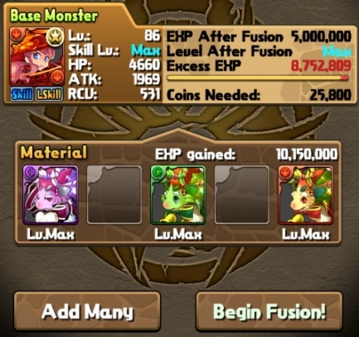

Figure 5.2‑12: Power-Up Fusion

Using Power-up Fusion will let your monster gain experience by consuming other monsters. The base monster gains experience based upon the monsters that were used in the fusion and the monsters used are destroyed. This is the only way to level up monsters in the game. Upon reaching the required amount of experience for a monster to level up, they will automatically level up and their HP, ATK, and RCV will generally increase. There are some exceptions to this where some stats will decrease or not change at all.

**Skill Up:** Upon performing a fusion upon a monster with another monster(s) will the same Active Skill there is a chance for the skill to level up or a Py (a monster) with the same primary attribute for a guaranteed level up.

**+ Fusion:** Upon performing a fusion upon a monster using a monster that has + stats, the + stats will be transferred to the base monster.

**Awakening:** For an awoken skill to become active, a monster must be powered up using a monster of the same class or a TMADRA.

##### Evolution



Figure 5.2‑13: Evo Tree

A monster is able to be changed into another class of monster when certain requirements are met. This is monster evolution.

These requirements include:

* Specified Level (of base monster)
* Monsters required in evolution*
* Coins

*Anywhere from one to several monsters will be fused into the base monster and destroyed upon evolution.

Upon evolution, numerous changes will occur:

* The monster ID and name will change.
* The active skill, leader skill, and awoken skills of a monster are subject to change upon evolution.
* The HP, RCV, and ATK of a monster may change upon evolution. Most monster’s stats will change, however not all do so.

###### Evolution Types

**Evo Fusion:**

* Upon performing this evolution, the monster’s level will be set to 1 and the evolution is not reversible.
* The prerequisites for this type of evolution are that a monster must be Max Level.

**Ultimate Evolution:**

* Ultimate evolution is a form of evolution in which a monster will change into another form with the ability to change back to the previous form.

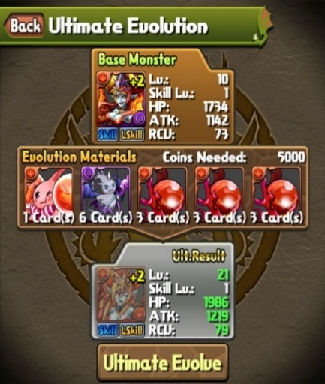

Figure 5.2‑14: Evolution

* Upon performing this evolution, the monster’s level will not be set to 1. Instead, the monster retains its current level and gain experience from the monsters used to evolve it.
* Ultimate evolutions are reversible and the monster does not need to be max level to perform this type of evolution.

**Devolution:**

* Devolution is the process of converting a monster to a previous form within it’s evolution tree.
* Devolution is only possible if the monster is an Ultimate evolution.

**Reincarnation:**

* Reincarnated evolution follows the same rules as evo fusion.
* Upon performing this evolution, the monster’s level will be set to 1 and the evolution is not reversible.
* The prerequisites for this type of evolution are that a monster must be Max Level.

##### Assists (Rank 130 required)

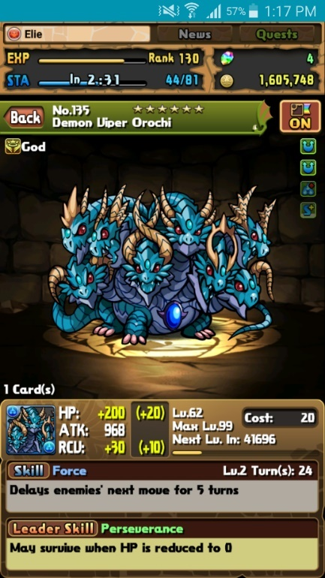

Figure 5.2‑15: Monster info

The monster chosen for an assist is known as the “Base Monster” and the monster chosen for assist is known as the “Assist Monster”. The concept of assisting monsters is to merge one monster with another so the Base monster will benefit by receiving potential properties from the Assist monster.

Assist requirements

* Any monster with a skill can be used as a Base Monster
* Assists are only available once a player reaches rank 10
* Only specific Monsters can be selected as an Assistant
* Only monster whom has all awoken skills awoken and is represented with a golden star icon on the monster’s profile in the monster box can be selected to be an assist.

Assist benefits

* If the Base Monster and the Assist Monster share the same Main Attribute, the Base Monster will receive a bonus to their stats represented as Blue +stats.
* The Base Monster will inherit the Assist Monster’s Active Skill. When gameplay, the player will have access an Assist Monster’s Active Skill through the Base Monster associate.
* Assisted monsters will have the secondary Active Skill displayed bellow the primary Active Skill.

##### Teams



Figure 5.2‑16: Edit Team

Teams are a group of a player’s monsters that are used to battle within dungeons. Teams are comprised of a team name, a leader monster, zero to for sub-monsters, and an Awoken Badge.

**Team Name:**

The team name is a small description of the team you are using. It is pre-set to a value and may be changed by the player.

**Team Stats:**

Team stats are split into these following sections:

|  |  |  |  |  |  |  |
| --- | --- | --- | --- | --- | --- | --- |
| Total Cost | http://www.puzzledragonx.com/en/img/allow/6.png | Team RCV | http://www.puzzledragonx.com/en/img/allow/2.png | Water ATK | http://www.puzzledragonx.com/en/img/allow/4.png | Light ATK |
| Total HP | http://www.puzzledragonx.com/en/img/allow/1.png | Fire ATK | http://www.puzzledragonx.com/en/img/allow/3.png | Wood ATK | http://www.puzzledragonx.com/en/img/allow/5.png | Dark ATK |

Table 5: Team Stats

The individual attack sections are all calculated using the cumulative ATK of the monsters in the team with that attribute. The amount of attack added for each attribute depends on whether a monsters has that attribute as their primary or secondary attribute. The Team HP is the cumulative HP of all monsters within the team and the RCV is the total RCV of all monsters in the team.

**Leader Monster:**

* The leader monster is the only mandatory monster within a team. When entering a dungeon, only the leader monster’s leader skill will be active.

**Sub-monsters:**

* A player is able to have anywhere from no sub-monsters to four of them.

**Total Cost**

Teams have a stat called Total Cost based upon their rank and awoken badge. This stat is a limitation that prevents certain teams from entering dungeons. Every monster has a cost stat based on a predetermined value for that monster. The cost of all the monsters is added together and if it exceeds the total cost then that team is unable to enter a dungeon.

**Awoken Badge**



Figure 5.2‑17: Awoken Badge

Each team may be assigned one awoken badge that will act as a modifier for the team. Badges may change to total ATK, RCV, HP, and/or Team Cost of a team. Badges other than team cost badges are disabled in multiplayer mode.

|  |  |  |  |
| --- | --- | --- | --- |
|  | Team Cost +100 | bind | Leaders Bind immune |
|  | Move Time +1 second |  | Team HP +15% / Team Cost -300 |
|  | Mass Attack |  | Move Time +2 seconds / Team Cost -400 |
|  | Team RCV +25% |  | Team RCV +35% / Team Cost -300 |
|  | Team HP +5% |  | No Skyfall Combos |
|  | Team ATK +5% |  | Team ATK +15% / Team Cost -300 |
|  | Skillboost |  |  |

Table 6: Awoken Badges

**Team Symbols**

Each of these three symbols correlates a player’s team. These symbols represent which helper monsters a player is able to see based on another players Team Symbol. These symbols are able to be seen when editing teams or when choosing a helper.

|  |  |
| --- | --- |
|  | Team 1 |
|  | Currently selected team |
|  | Team 2 |

Table 7: Team Symbols

#### Dungeons

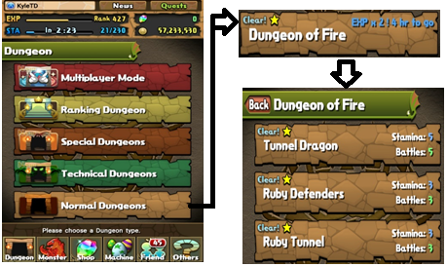

Figure 5.2‑18: Dungeons & Sub-Dungeons

Dungeons are a feature within the Puzzles and Dragons video game in which players use teams of monsters to fight other monsters. A dungeon is comprised of one or more floors, each of which contains one or more monsters that must be defeated to proceed to the next floor. Upon defeating all the monsters within a dungeon, the user will obtain rewards.

Dungeons consist of sub-dungeon(s) that can be cleared to obtain magic stones and clearing all sub-dungeons within a dungeon will grant that dungeon a cleared status.

##### Dungeon Entrance

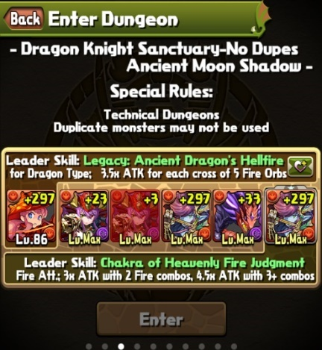

Figure 5.2‑19: Dungeon Entrance

All dungeons have specific requirements that must be met before entering. Each dungeon has a stamina cost a player must pay to enter as well as the possibility to have one or more requirements. These requirements include but are not limited to:

* No duplicate monsters (except helper)
* All Attributes Required
* Specified monster required to be on the entering team
* No more than a specified number of monsters on team

In addition to the entrance requirements, dungeons may also have global modifiers placed upon them. These modifiers include but are not limited to:

* Board size modifiers
* Orb types appearance modifiers
* Assists invalid
* Awoken Skills Invalid
* Leader Skills Invalid
* Type Enhanced (1.5x monster stat multiplier)
* Attribute Enhanced (1.5x monster stat multiplier)
* No Continues
* Fixed Team
* Fixed Orb Movement Time
* No Skyfall orbs (orbs do not fall until your turn is finished)
* Stamina modifiers
* Drop rate modifiers
* Experience modifiers

You are able to bring in a helper monster (one of your friend’s monsters) to assist you in the dungeon.

Your leader monster, as well as your helpers’ monster leader skill will be active (unless dungeon modifiers specify otherwise).

##### Dungeon Completion

**Dungeon Rewards:**

Upon clearing a dungeon, a player will receive rewards. These rewards may include player experience, coins, magic stones, pal points, monster points, and monsters that you defeated within the dungeon. On top of these, clearing certain dungeons will result in a reward that will be sent to the in-game mail system.

Many of these rewards are available after each time a dungeon is cleared with the exceptions of magic stones, monster points, and pal points.

* Magic stone rewarded for the first time you clear a dungeon.
* Monster points are earned when clearing a dungeon in multiplayer.
* Pal points are only obtained when you have not played with the helper you entered in that day or through multiplayer.
* Not all monsters are obtainable even if they are found within a dungeon and the monsters that are obtainable from a dungeon may be a different evolution than the one defeated within the dungeon.

##### Normal Dungeons

* A series of dungeon in which dungeons are cleared in a specific order.
* When one dungeon is cleared the next one will be unlocked for a player to play.
* In certain cases, clearing a dungeon will unlock multiple dungeons or no dungeons.

##### Special Dungeons

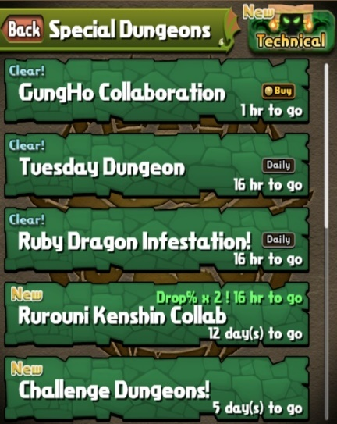

Figure 5.2‑20: Special Dungeon Menu

* Daily Dungeons (Dungeons are available based on the day of the week)
* Descended Dungeons
* One-Time Dungeons (only available before it is cleared for the first time)
* Reward Dungeons (rewards are only given for first time clears)
* Event Dungeons (Dungeons available for a limited time during events)
* Coin Dungeons
  + Coin Dungeons are available for a limited time in the multiplayer section after purchase in shop.
  + Coin dungeons with the same names as other dungeons do not share their clear status.

##### Technical Dungeons (Rank 10 Required)

* Clearing and unlocking dungeons works in the same manner as Normal Dungeons
* Clearing Castle of Satan in the Abyss will unlock a dungeon mode called challenge mode.
* Challenge Mode Dungeons are Normal and Technical dungeons that may be cleared in Challenge mode for an extra stone after they have been cleared once.

##### Multiplayer Dungeons (Rank 30 Required)

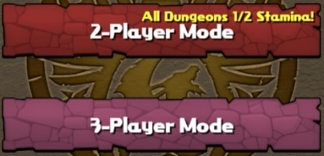

Figure 5.2‑21: Multiplayer Modes

* Available in 2-player mode and 3-player mode.
* 2-player mode allows two players to enter a dungeon together. The leader monsters are shared and the subs are switched each turn. The health pool is shared by both players.
* 3-player mode allows 2-3 players to enter a dungeon together. In this mode players choose their friend leaders and do not share any stats with each other.
* Dungeons share cleared status with dungeons from other categories.
* Dungeons from other categories such as Special Dungeons (except reward dungeons) and technical dungeon are available in 2-player mode.
* Clearing a Technical dungeon in multiplayer will unlock it for the guest player and mark the dungeon as cleared if it has not yet been unlocked or cleared for that player.

##### Ranking Dungeons (Rank 150 Required)

* All players are ranked based on the points they obtain while the dungeon is available, compared to all of the players that have cleared the dungeon.
* Ranking dungeons are only available for a limited amount of time.
* Upon the completion of this time, all the players are evaluated and the players within the top one percent of players are granted an achievement called a Crown.

#### Quests

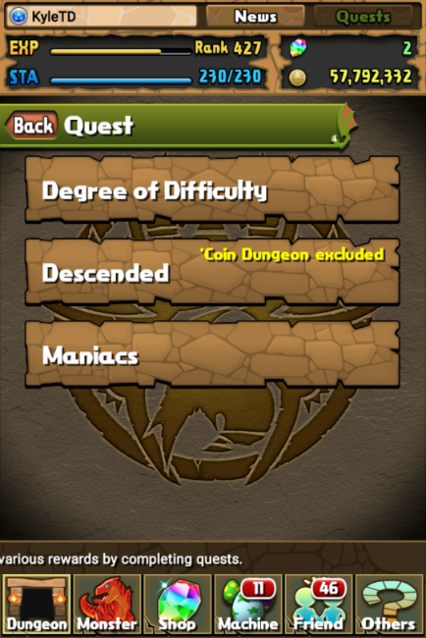

Figure ‑: Quest Screen

Quests are goals for the player to complete, these quests are grouped into sections found on the quest screen. Each quest within the section containing sub-quests. Each sub-quest offers the player a reward upon completion that may be of the following things: currency, monsters, or dungeons. Sub-quests can range from completing dungeons and expanding your monster box to beating descended dungeons and placing well in the ranking dungeons. Quests offer rewards upon completion of their individual sub-quests with rewards offering dungeons or awoken badges.

#### Friends

Friends are other players that you interact with on a daily basis. You can use their leaders as helpers in dungeons to get bonuses, send personal messages to them, and you can let them join you in multiplayer dungeons. Player starts off with 20 friend slots and gains more while ranking up, up to 50 slots. Friend slots can be purchased with magic stones, 1 stone unlocks 5 friend slots.



Figure 5.2‑27: Friend Menu Navigation

##### Gaining Friends

* Accepting a friend request
* Sending a friend request to a non-friend helper
* Sending a friend request to a specific player ID

##### Friend Types

Non-Friends:

Non-Friends are player that is not on your Friend List and labeled as User in Select a Helper screen. If used as a helper you are given a chance to send a friend request after successfully completing that dungeon. Can only access their current leader

Friends:

Figure 5.2‑28: Select a Helper Screen

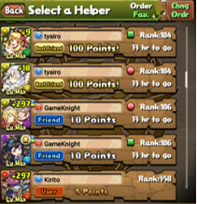

A player found in Friend List and they are labeled as Friend in Select a Helper screen. Can access their first (Rank 40 Required) and current leader. Friend leaders are not selectable if that friend has not logged in within 24 hours and each leader can only be used once, every time that friend logs in.

Best Friends (Rank 50 Required[1]):

Listed as best friend in Friend List and labeled as Best Friend in Select a Helper screen. Can access their first, second, and current leader. Best friend status’ are two ways, meaning if one friend upgrades a friend to a best friend, both player have the best friend status for each other. Best friend’s leaders are available all day no matter how many times they are used so long as the best friend has logged in within the day. Best friend selection is periodically reset[2].

##### Friend List

Figure 5.2‑29: Friend List

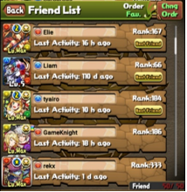

The friend list is used to view all of your current friends with their current team’s leader. Here you can choose to:

* Add to Favorites – Gives a friend a favorite status, represented as a rainbow icon, preventing you from deleting that friend as well as making them easier to find in both the Friend List and Select a Helper screens
* Check Info – Displays the information of the friend’s current leader
* Delete[3] – Removes that friend from your friend list, does not appear if friend is favorited
* Remove from Fav. – Removes the favorite status from a friend, allowing you to once again delete them from your Friend List (Only appears if that friend is favorited)

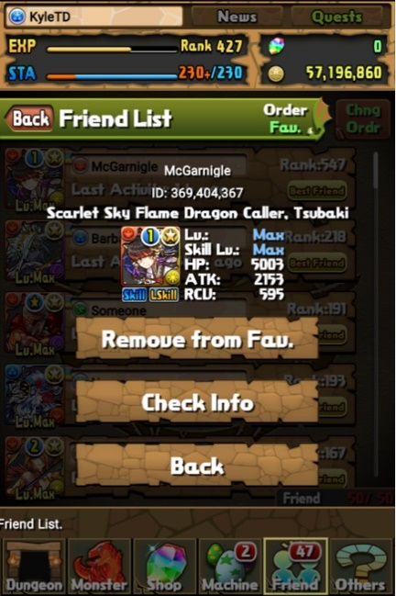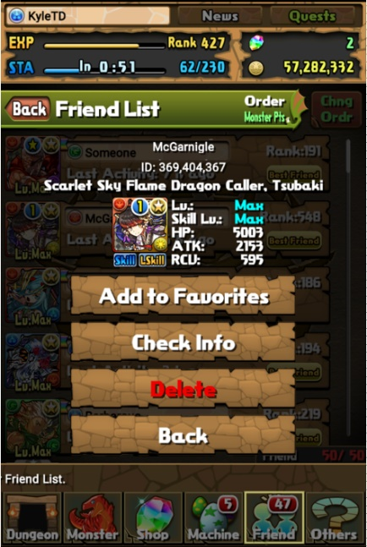

Figure 5.2‑30: Friend Options

#### Mail System

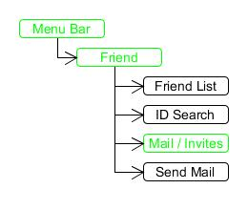

Figure ‑: Mail Navigation

The mailing system in Puzzle and Dragons is an in-game communication system that is used to send and receive messages and notifications. Messages allow two-way communication between friends. Notifications are one-way communications sent by the Game Admin. Notifications can contain different items that can be claimed.

##### Mail Functions

***Open*** Open the message

***Delete*** Removes this mail from your inbox

***Ok*** Closes the message or notification.

***Reply*** Sends a reply message to the sender of the message.



Figure ‑: Mail Expiry

***Protect*** Prevents the deletion of this message until protection is removed.

***Unprotect*** Removes protection from the message.

***Begin***  Activated a claimable attachment in mail

***Mail Expiry*** Claimable attachments have a time limit before the become Unclaimable.

##### Mail Screen

The Mail Screen displays the messages the Player currently has, notifications are marked as “From Game Admin”.

##### Mail Sorting / Deleting

There are the various sort options for mail that are accessed by selecting “Sort / Delete” in the top right corner of the Mail Screen. You can purge read message in the mail screen with “Delete all read mail”.

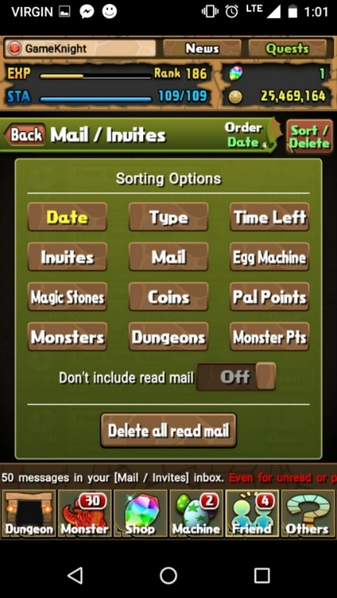

Figure ‑: Sort / Delete

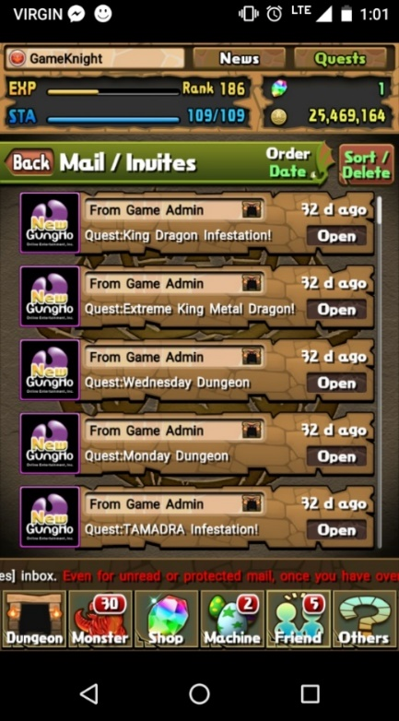

Figure ‑: Mail Screen

#### Shops

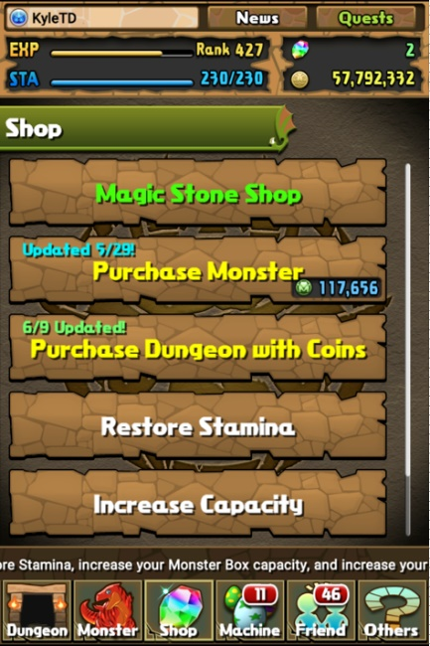

Figure 5.2‑32: Shop Menu

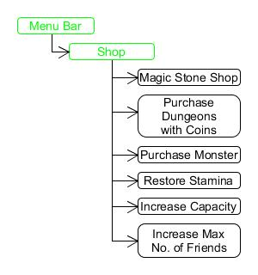

Figure 5.2‑31: Shop Navigation

Shops are where a player can purchase monsters, dungeons, stamina, monster box upgrades, and friend list upgrades.

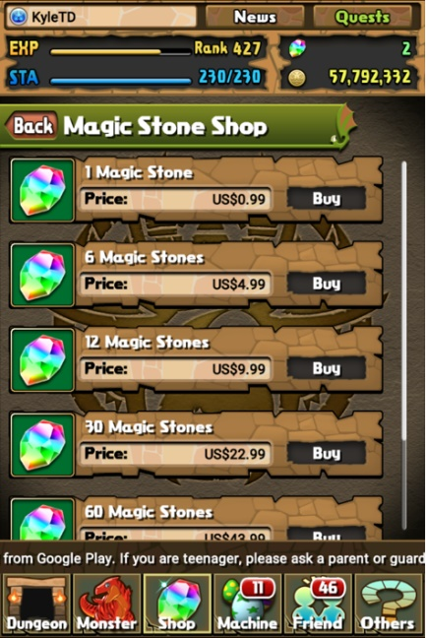

Figure 5.2‑33: Magic Stone Shop

##### Magic Stone Shop

Magic stones are Puzzle and Dragons’ premium currency. They are used to access premium content. Here a player can purchase Magic Stones with real money, this type of transaction is referred to as a microtransaction. Different sized bundles are available for purchase.

##### Purchase Monster (Rank 60 Required)

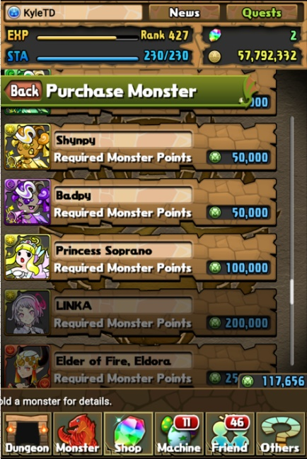

Figure 5.2‑34: Purchase Monster

Here a player can purchase monsters using Monster Points. Monsters included in this shop do change periodically.

Examples of Monsters available:

* Evolution Material
* Enhance Material
* Exclusive Monsters

##### Purchase Dungeon with Coins (Rank 80 Required)

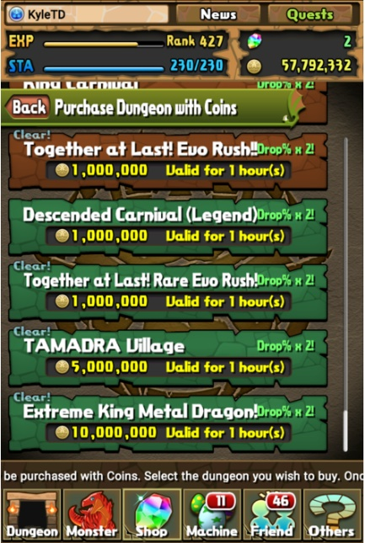

Figure 5.2‑35: Purchase Dungeons with Coins

Here a player can purchase dungeons with coins. The dungeons listed change periodically. After successfully purchasing a dungeon, that dungeon appears in the Special Dungeons and will stay there for the time specified. You are able to play that dungeon as many times as you want within the time span and you can buy the same dungeon multiple times. You can only have a single dungeon purchased at a time, if you purchase another before the time has runs out the previous dungeon will be replaced with the new one.

##### Restore Stamina

If a player does not have a full stamina bar then they are able to use the Restore Stamina shop. For a single magic stone the player will receive a boost to their stamina (For example: a player has a total stamina of 100, if they restore stamina they will receive 100 stamina). If the restored stamina exceeds the player’s total stamina the excess stamina is placed in a kind of reserve, meaning the player will temporarily have more stamina then their total stamina.[4]

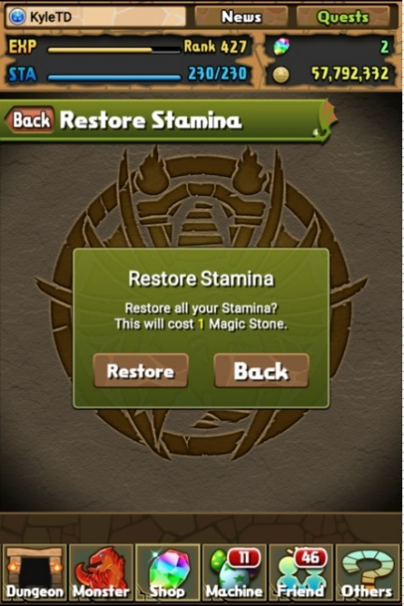

Figure 5.2‑36: Restore Stamina

##### Increase Capacity

Here a player can increase the size of their monster box for magic stones. Increasing the size of a player’s monster box benefits the player as it allows them to store more monsters, whether they be Evo Material, rare monsters, or monsters the player just enjoys.

##### Increase Max No. of Friends

Here a player can increase the size of their friend list by 5 for 1 magic stone. Increasing the size of a player’s friend list benefits the player allows them to add more friends, giving them access to more helpers.

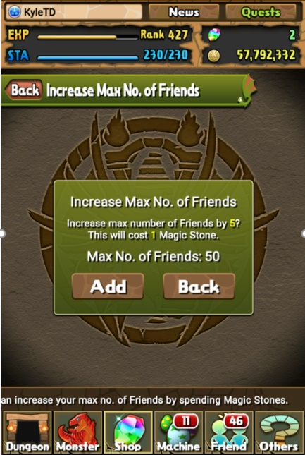

Figure 5.2‑37: Increase Max No. of Friends

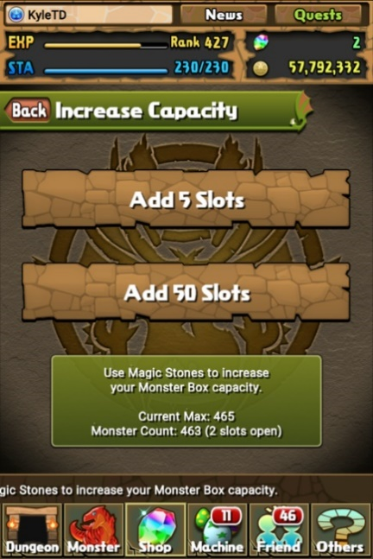

Figure 5.2‑38: Increase Capacity

#### Egg Machines

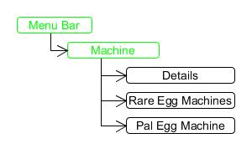

Figure 5.2‑39: Machine Menu Navigation

Egg machines are a feature found in Puzzle and Dragons that allows users to collect new monsters as well as monsters you may already have. The monsters that appear from this are randomised and usually based on current egg machine modifiers. These monsters appear in 6 different types of eggs that are based on the rarity of the monster contained within.

##### Using Egg Machines

There are several types of egg machines currently in Puzzle and Dragons each of which allows you to play for multiple eggs at a time these include:

* PAL Egg Machine
  + An egg machine that you spend PAL points on to receive monsters
* Rare Egg Machine
  + An egg machine that you spend magic stones on to receive monsters
  + Event Egg Machine (this is a type of rare egg machine)
    - Egg machine that pertains to specific events that happen throughout the year

To use these machines, you must have the correct amount of currency for the machine you want. After selecting the machine you want, you will be taken to a screen with the egg machine on it, to move from this screen you will hold on the machine’s arm and pull it down (this process is known as “playing”). After you pull you will see an animation of an egg coming from the machine, the color or pattern will determine the rarity level of the monster. You will then be taken to a screen showing the monster egg being opened followed by a screen which shows the monster’s information and stats.

##### Egg Machine Availability

Egg machines are on a rotation, these rotations affect the drop rates of monsters as well as the drop pools (which monsters can drop).

This is a list of some of the different available egg machines

* Events
  + If there is a special limited time event there will be drops based on that event
* Galas
  + There will be periods of time where monsters of certain primary attributes will have a higher chance of dropping
* PAL Rotation
  + The PAL egg machine has a rotation of different monsters that can drop from it ranging from monsters used for evolving to rare monsters
* Bonus Monsters
  + During an egg machine rotation, you may receive an extra monster for using a machine
* Increased rates
  + During an egg machine rotation, certain monsters will drop at an higher rate than normal

##### Event Egg Machine Types

Event egg machines are one of the communities’ favorite egg machines as they can offer unique and rather powerful monsters. These egg machines can come in a few different types

* Holidays
  + Sometimes through the year there will be a holiday egg machine these will drop monsters associated to these holidays
* Series
  + Through the year Gung-Ho will release updates to certain monster series’ that they deem necessary for their own egg machines
* Collaborations
  + On occasion, Gung-Ho will team up with another company whether it be a game company or an anime company in order to release monsters from content produced by the partner company for example Final Fantasy Collaboration

### Application Concepts

#### Application Overview

The idea behind PADification was to have an application allowing players of PAD, both new and old, to list the monsters they have collected or wanted and create teams using these monsters. Players will be able to view and rate the teams created by other players and view other players’ monsters and wishlisted monsters. The purpose of this was to cooperatively provide players with new and existing team ideas with the intent of discovering the best made teams a player can make with their monsters.

#### Account

An account of PADification allows a person to access the application. A player may create an account using specified credentials. Logging in allows the user to access their PADification account. To login a user will enter their specific credentials. A user may update their email and password from the account options screen.

#### Monster

The PADification product will support all the information available on the monsters found in the North American version of the Puzzles and Dragons video-game. This information will be accessible to players as a list, players will be able to filter the list as well as search for specific monsters via a search feature in the PADification product. Players will be able to select monsters from the list and view a specific monster’s information and/or select the monster to be added to the player’s wish list located in the collection section of the PADification product.

**Players**

Players will have access to a feature where they may modify any monster in their collection. The players will be able to make changes to a monster’s properties. This feature exists so players will be able to see the potential of a monster at the stage they wish. Monsters that have been edited will have the date of the update registered to keep track of how much time has passed during the monster’s growth. Players will be able to rank monsters by using “tags”. Tags will help players identify which monster may be better over others in certain situations by the amount of points a tag receives.

Monster properties that can be edited:

* Amount of exp the monster has. (their level)
* Yellow Plus stats
* Awoken skills activity
* Latent skill equips
* Assists (and all modifiers that follow)

Monster Tags:

* Leader monster
* Sub monster
* Assist
* Orb modifier
* Damage dealer
* Healing
* Health Pool
* Defensive
* Offensive
* Jammer destroyer
* Poison destroyer

**Admins**

Administrators will have access to all the features available to players listed above, with the addition of accessing the PADification database. Admins will be responsible for the upkeep of the monster information, they will be in charge of handling all tables of the PADification database. Admins will be able to moderate the players using the product.

#### Collection

The monster classes and instances found in a player’s Monster Wishlist and Monsters Crate as well as the Monster Book are all displayed within the Collection. The player should be able to add multiple monsters at once to either their Monster Crate or Wishlist by selecting multiple monsters from the Monster Book.

##### Monster Book

A list of all NA monsters. The monsters within the monster book will be able selected and added to monster Crate or Wishlist

##### Monster Crate

The Monster Crate is a list of the monsters a player owns. A player will be able to edit these monster’s statistics, assists, and Latent Skills if it within their Crate.

##### Wishlist

The Wishlist is a list of monsters that a player does not own but wish they did. A player will be able to edit these monster’s statistics, assists, and Latent Skills if it within their Wishlist. The player will be able to add these monsters to a players Monster Collection directly from the Wishlist.

#### Team

##### Creation

Team creation will be similar to how teams are created in PAD, the exception being the inclusion of the wishlist feature PADification provides. Players will be able to create teams using monsters from both the monster crate and wishlist. Players will be able to see the changes to each stat as they add and remove monsters from the team.

##### Updating

Players will be able to update their previously built teams to accommodate for, updates of the game or new ideas for that team. Game updates, in this case, could consist of existing monsters being changed or new monsters being added to the game.

##### Deletion

Players will be able to delete teams they no longer want/have.

##### Viewing

Players will be able to view summaries of teams, consisting of the monsters on the team and the stats of the team, while browsing teams, when the Player clicks one of these summaries a more detailed view of the team will open.

#### Social

Padification will allow Player to have community interactions, for the purpose of finding popular and efficient team compositions. There will be no direct communications or discussions, only a Ranking system for teams and monsters driven by a tagging system for identifying the particular role.

##### Searching

Players will be able to search the database for players and teams and filter any results:

**Players**

* Players will be able to search for Players by User Name or Player ID Number.
* Players can sort results by Followers, Date joined, and Alphabetically.

**Submitted Teams**

* Players will be able to search for Teams by Team Leader, Attributes, Sub Monsters, and Creator.
* Players can sort results by Popularity, Date Created, Attributes.

##### Following

Following a Player will add that Player to the Following list, for easy access to that Players Collection. When the followed submit a new team the following are given notifications on the home screen.

##### Team Rating

Players will be able to Submit Teams to the Community allowing Players to like or dislike, the player Tags the Team on submission to identify the Purpose of the team Composition. The top 5 Rated teams will be displayed on the home screen, along with the Top 5 new teams.

##### Monster Rating

Players will be able to Rate tags on a Monster to indicated which role this monster Fits best, and its strong points.

##### Tagging

Monster will have all tags associated with them to be individually like or disliked, Teams will have Tags attached to them, only allow to like or dislike the team itself.

## Practical Considerations

## Requirement Information Items

# Processes

## Requirements Processes

### Game Processes

#### Navigation

In Puzzle and Dragons, the main way of getting from point A to point B is by tapping on the screen. A scrollbar is in place on pages where there is additional content that cannot be seen immediately, a player may swipe their finger up or down to view this additional content. A “Back” button can be found on some pages, with this button players may return to the previous screen.

#### Player Process

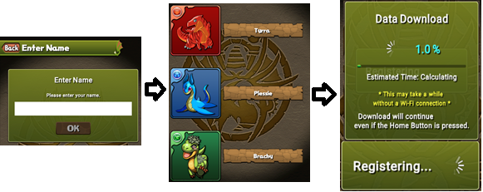

Figure 6.1‑1: Account Creation Process

##### Account Creation

* Accept the Puzzles & Dragons Terms of Service after Reading them
* Enter your player name and press ok
* Select your beginner monster
* Complete the tutorial

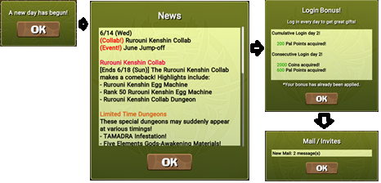

Figure 6.1‑2: Logging In

##### Logging In

A player is able to log in once a day to receive rewards.

* “A new day has begun!” message pops up.
* News is displayed
* Login bonus message is displayed
* Mail / Invites Message is displayed
* Mail / Invites screen is opened

##### Rank Up

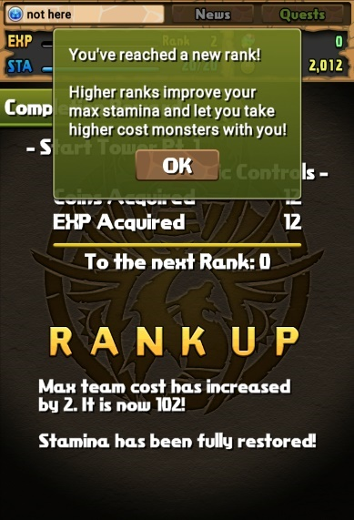

Figure 6.1‑3: Rank Up

Upon Completion of a dungeon, a player may rank up if they gain enough experience.

* Complete a dungeon
* Receive experience greater or equal to your “To the next Rank:” experience requirement
* Your rank increases

##### Change Name

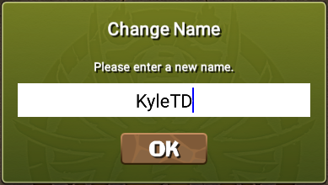

Figure 6.1‑4: Change Player Name

* Navigate to name change: Others -> User info -> Change Name
* Enter a new name and confirm
* You now have a new name

#### Selling Monsters

1. The player may select the “Manage Assists” option found under “Monster” on the Menu Bar.
2. All monsters can be sold[5].
3. Monsters that are labelled under favorites or in-use cannot be selected and sold[6].
4. Players may select and sell multiple monsters at once. Selecting a monster will change the monster card to grey and place a numbered icon in the middle.
5. Once a player is ready, they must press the “OK” button.
6. A prompt will appear asking the player if they wish to proceed. Pressing “Yes” will officially sell the monster meaning they will be removed from the player’s roster permanently. This action will give players both Monster Points and Coins when finishing the transaction.
7. If a player selects “No” on the prompt, the transaction is cancelled and the player is returned to his list of monsters[7].
8. Pressing on a selected monster will cancel the selection and so, that monster will not be sold.
9. To unselect monsters, players can press the “Clear” button unselect all monsters at once.

#### Power-Up Fusion

To perform a Power-Up Fusion:

1. Select “Monster” from the Game Navigation Bar.
2. Select “Power-Up Fusion” from the Monster Menu.
3. Select the Base Monster to perform the Power-Up Fusion on.
4. Select an empty Material Slot, or for multiple selection select “Add Many”.
5. Select the Monster/Monsters to be used as material.
6. Ensure your Coins are greater or equal to “Coins Needed”.
7. Select “Begin Fusion!”
8. If Material has rarity greater you must confirm the Power-Up Fusion.

**Leveling**

Performing Power-Up Fusion on the Monster with material/materials that grant “EXP gained” greater or equal to “To Next Lv.:” value will result in the Monster Leveling up.

**Awakening**

Performing Power-Up Fusion on the Monster with the Awoken Material “TAMADRA” or “Baby TAMADRA” or with a Monster with identical Monster ID will awaken that Monster. Note that “Baby TAMADRA” only has a 50% chance of Awakening.

**Skill-Up a Monster**

|  |  |
| --- | --- |
| Primary Attribute | Py Enhance Material |
| Fire | Flampy |
| Water | Bubpy |
| Wood | Woodpy |
| Light | Shynpy |
| Dark | Badpy |

To Skill-Up your Monsters Active Skill, perform Power-Up on the Monster using the Enhance Material “Flampy, Bubpy, Woodpy, Shynpy, or Badpy” of the corresponding Primary Attribute. If the Monster is an Ultimate Fusion and level 99, Using another Monster of the same Monster ID that is also level 99 as Material will also Skill-Up your Monsters Skill.

Table 8: Py Chart

Performing Power-Up Fusion with a Monster with the same Active skill will have a 10% chance of granting a Skill-Up.

**Plus Stat (+) Enhancement**

Performing Power-Up Fusion on the Monster with Material that has the Plus Stat will add those Plus Stats to the Monster. Note Plus Stats will only Increase the Stat that the Plus stat is attributed to; Plus ATK will not increase Plus HP vice versa.

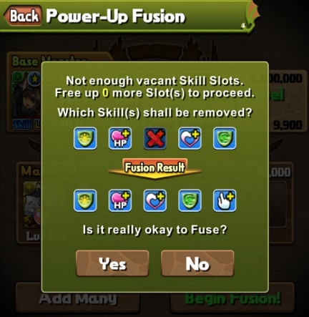

Figure 6.1‑5: Latent Skill Replacement

**Latent Skill**

Performing Power-Up Fusion using a “Latent TAMADRA” as material will grant any monster (Excluding “Evo Material”) a Latent Awakening Skill corresponding to the “Latent Tamadra” Used as Material. If a Monster is Latent Slots are full, the Player chooses the Latent Awakening Skill that will be Replaced. If “Extra Latent Slot Tamadra” is used as Material, the Monster will gain another Latent slot (Maximum of 6).

#### Evolution

To perform an Evolution:

|  |  |  |
| --- | --- | --- |
| * Select “Monster” from the Game Navigation Bar. | | |
| * Select “Evolution/Ultimate Evolution” from the Monster Menu | | |
| * Select a Monster with an available evolution. Marked with a Red Blinking Arrow to the right of the Portrait. | | |
| **Evo Fusion** | **Ultimate Evolution /**  **Ultimate Devolution** | **Reincarnation** |
| * Ensure Your Monster is Max Level and you have the required Materials and Coins. | * Select the evolution intended. | * Select the Reincarnation |
| * Select “Evolve” | * Ensure you have the required Materials and Coins. | * Ensure Your Monster is Max Level and you have the required Materials and Coins. |
|  | * Select “Ultimate Evolve” / “Ultimate Devolution” | * Select “Evolve” |

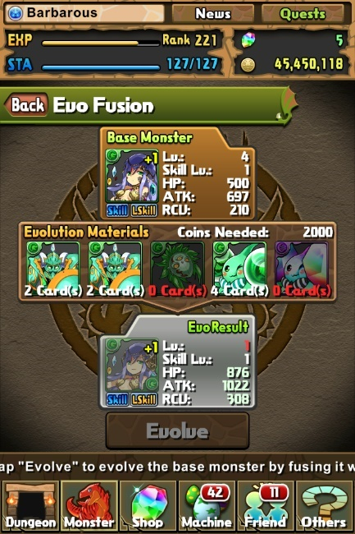

Figure 6.1‑8: Evo Fusion

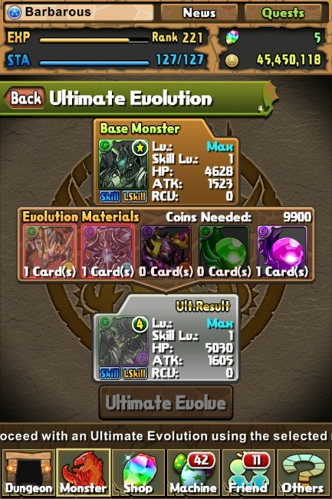

Figure 6.1‑8: Ultimate Evolution

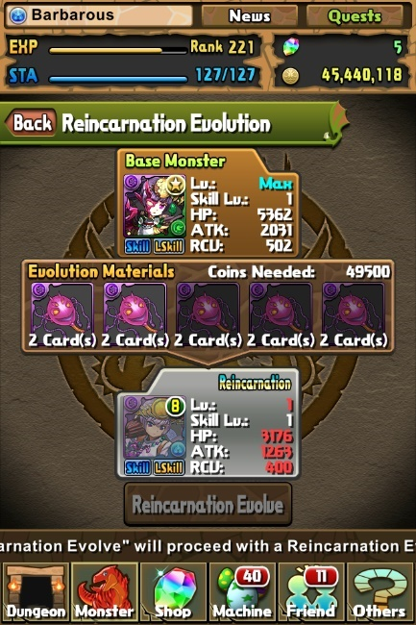

Figure 6.1‑8: Reincarnation

#### Assists

##### Assists Process

1. The player may select the “Manage Assists” option found under “Monster” on the Menu Bar.
2. Selecting this option, the player will be sent to a list of their monsters.
3. The monsters available to be used as Base Monster will be fully colored and those who can’t, will be greyed out.
4. Once a monster is selected, a prompt will be displayed instructing the requirements for assistance. Confirming the prompt will send the user to his list of monsters once again.
5. Here, the monsters available to be Assist Monsters will be fully colored and those who can’t will be greyed out.
6. Player can always revert the assist if they wish. Simply, repeat the steps but instead, select the monster whom is already assisted and confirm they wish to undo the assist.

##### Assist Monster Gameplay

1. An Assisted Monster will play exactly the same as any Monster with the exception of the Secondary Skill.
2. The Assist Monster’s Active Skill can only be used after the Base Monster’s Active Skill is charged.
3. Once the Primary Active Skill is Charged, the player may use that Active Skill.
4. The secondary Active Skill Must also be charged in order to be used[8].
5. If players use the primary Active Skill, the process will restart from the very beginning.

#### Edit Team

First the player selects the monster slot they want to edit. Once a slot is selected, the Select a Monster screen will open. If you are editing the leader slot then you will only be able to select a monster that is not currently on that team, as a team must at least have a leader.

Sub monsters can be removed from a team, leaving that slot empty.

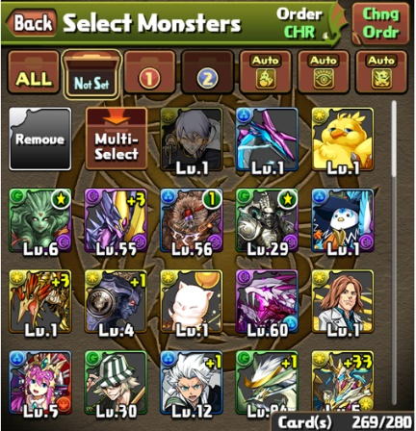

Figure 6.1‑9: Editing Subs

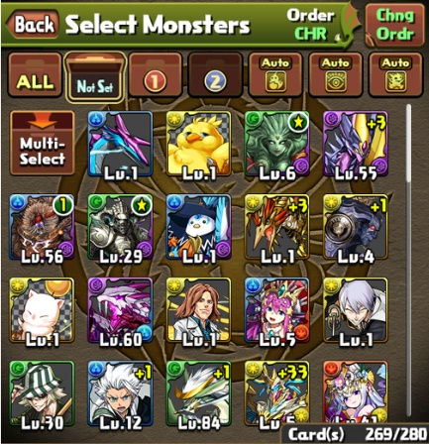

Figure 6.1‑10: Editing Leader

##### Select at Once

Another way to edit a team’s monsters is to use the select at once button. Select at once allows the player to select 5 monsters to place on the current team (In this order: Leader, Sub 1, Sub 2, Sub 3, Sub 4). You can remove monsters using select by reselecting the same monsters, or you can remove all the monsters currently on the team by using the clear button.

##### Changing Awoken Badges

Awoken Badges can be changed, different Awoken Badges provide teams different boosts. Select the Awoken Badge icon[9] beside the Leader banner and select a new Awoken Badge.

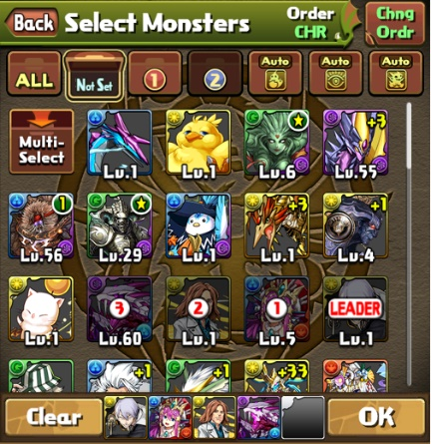

Figure 6.1‑11: Select at Once

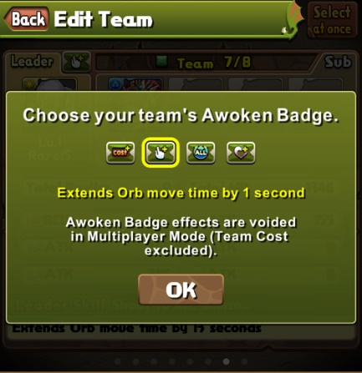

Figure 6.1‑12: Changing Awoken Badge

##### Renaming Teams

Each team is given a default name, a player can change that name to suit their needs easily. Simply select the team name (Represented as “Team” in figure 6.1-13) and input the desired name (Figure 6.1-14).[10]

##### Unlocking Additional Teams

Each player begins with 6 teams, but as they rank up players can unlock additional teams. A player unlocks a new team slot every 100 ranks.[11]

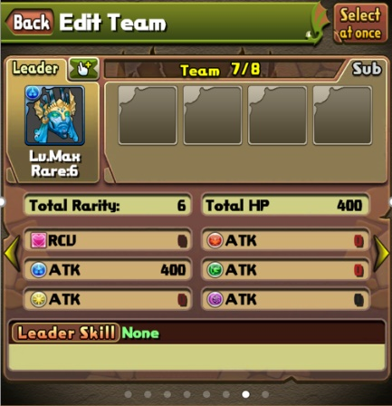

Figure 6.1‑13: Edit Team Screen

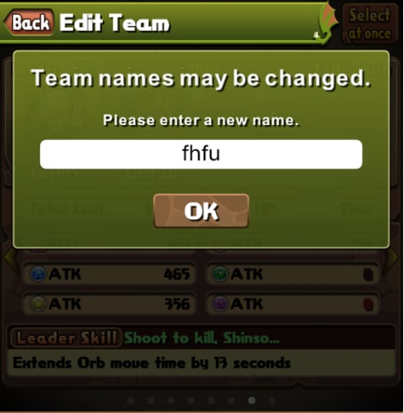

Figure 6.1‑14: Editing Team Name

#### Dungeon Gameplay



Figure 6.1‑15: Dungeon Gameplay Process

The basics of dungeon gameplay is a player entering a dungeon where they match orbs of the same type to create combos.

* Monsters on your team with the corresponding orb types will attack.
* Creating certain combos will allow you to activate certain leader skills as well as certain awoken skills.

The base process for a single player is:

* Player selecting a dungeon of choice
* Player choosing a helper or choosing to enter without helper (or challenge mode when available)
* Player choosing a team to enter the dungeon with and entering
* Defeating all monsters on a floor to proceed to the next
* Clearing all floors to complete the dungeon
* Claiming rewards upon exiting the dungeon

If your health reaches zero with the dungeon, you are either able to pay one magic stone to continue or give up and exit. Giving up will result in no rewards. Certain exceptions may apply.

Multiplayer dungeon gameplay is similar to that of a single player in that the core gameplay from dungeons remains the same. However, the turn order must accommodate the extra player(s). The order will begin with the player who has created the Room followed by the other player(s). (If 3 players are present, the 2nd player to join the Room will go next, followed by the 3rd player to join the Room.)

##### 2-Player Mode Gameplay

2-Player mode gameplay is similar to single player with some key differences.

* It starts off with a player choosing a dungeon and inviting another player or players to join their room



Figure 6.1‑16: Two Player Turn System

* Once the other player has accepted, then both players choose their team and press ready/play
* Once in the dungeon the players take turns matching orbs
* Defeating all monsters on a floor to proceed to the next
* Clearing all floors to complete the dungeon
* Claiming rewards upon exiting the dungeon

Unlike in single player mode, the helper monster in 2-Player mode is the leader monster of the other player in the room. If a player disconnects then the game is switched to single player mode.

##### 3-Player Mode Gameplay

3-Player mode gameplay is somewhat of a mixture between single player mode and 2-player mode.



Figure 6.1‑17: Three Player Turn System

* It starts off with a player choosing 2-player or 3-player dungeon mode
* The player chooses a dungeon and chooses their monster leader.
* They then invite another player or players to join their room
* Once the other player(s) have accepted and chosen their helper leaders, then all players choose their team and press ready/play
* Once in the dungeon the players take turns matching orbs
* Defeating all monsters on a floor to proceed to the next
* Clearing all floors to complete the dungeon
* Claiming rewards upon exiting the dungeon

As in single player mode, players will use their chosen helper and not the helper of the friend(s) that entered with them. Like in 2-player mode, if one player disconnects, then the game will continue with the other player(s).

##### Multiplayer Mode (Rank 30 required)

**Description**

Puzzles and Dragons offers a multiplayer mode where 2 to 3 players can join forces and tackle dungeons together. Certain multiplayer options will result in the Stamina cost for entering a dungeon to be diminished for the collaborating players.

**2-Player Mode**

Multiplayer Dungeons for 2 players.

* Create a Room (Room ID)



Figure 6.1‑18: Input Room ID

* + 2-Player mode demands that one player creates a Room by selecting from the list of available Special Dungeons. Next, they wait for another player to join the Room. Once the Room is created, and while waiting for other players, the player may copy the newly generated Room ID or share the Room ID to all the player’s registered friends or to specific friend(s). This will send a notification to the player’s friends in the Mail / Invites section under Friend.
  + When All players are ready, the group proceeds to the gameplay.
* Enter a Room ID
  + Here, the player may input an existing Room ID they have acquired via a friend’s invitation or other means.
* Find a Friend’s Room
  + If the player’s friend has created a Room, other players may view that Room in this section. Furthermore, a player may press the available Room and ask to participate with the Room’s creator in their endeavors.

**3-Player Mode**



Figure 6.1‑19: Dungeon Menu for 3-Player Mode

Multiplayer dungeons for 2 or 3 players.

* Search for a Partners (Auto-Match)
  + This option allows a player to Create a Room by Selecting a dungeon from the Multiplayer dungeon list and selecting their helper monster. Next, the player’s Room will automatically wait for other players from around the world to join them and proceed to the gameplay with the matched partner(s).
* Create a 2-Player Room (Room ID)
  + This option allows a player to Create a Room for him and one more player to join. They will select from a list of the available Multiplayer Dungeons. Next, they wait for another player to join the Room. Once the Room is created, and while waiting for other players, the player may copy the newly generated Room ID or share the Room ID to all the player’s registered friends or to specific friend(s). This will send a notification to the player’s friends in the Mail / Invites section under Friend.
  + When all players are ready, the group proceeds to the gameplay.
* Create a 3-Player Room (Room ID)
  + This option allows a player to Create a Room for him and two more players to join. They will select from a list of the available Multiplayer Dungeons. Next, they wait for two other players to join the Room. Once the Room is created, and while waiting for other players, the player may copy the newly generated Room ID or share the Room ID to all the player’s registered friends or to specific friend(s). This will send a notification to the player’s friends in the Mail / Invites section under Friend.



Figure 6.1‑20: Created Room

* + All players are ready, the group proceeds to the gameplay.
* Enter a Room ID
  + First, the player is asked to select a Helper Monster from their list.
  + Next, the player may input an existing Room ID they have acquired via a friend’s invitation or other means.
* Search for a Room
  + First, the player is asked to select a Helper Monster from their list.
  + Next, the player may select to join an existing Room from other players across the world.

**Game Mechanics**

* During the gameplay, each player only has access to their respective monster’s Active Skills with the exception of the team member’s Leader Monster’s Active Skill.
* The Team’s HP stat is comprised of the sum of each player’s collective HP stat from their individual teams.
* If the group’s HP reaches zero, (signaling a game over) the player who’s turn fell on the game over will have 30 seconds to use a Magic Stone in order to continue playing or the player may choose to quit the dungeon.
* In the case of a game over, players will not be able to purchase Magic Stones in multiplayer mode.

### Application Process

#### Account

**Creation & Access**

To make an account a player will enter their Puzzle and Dragons ID, their email, a unique username, and a password into their respective input fields. To access their account a player shall enter their username and password into their respective fields.

**Updating Account Information**

If a player wishes to update their account information they must go to the account section of PADification click “Edit Information” and modify allowed fields (email and password).

#### Monster

Monsters can be found and interacted with in 2 sections; the player collection and monster book sections.

Player collection screen

1. From any page, press the Player Collection button.

Monsters found in the player collection can be categorised by being monsters owned by a player, monsters favorited by a player and monsters under Wishlist. By selecting a monster in the collection, players will be able to view the monster’s information as well as the evolution of the monster. This information will be displayed to the right of the collection list. Players will have access to a few options; Add to favorites, edit monster, remove monster. In the event that a monster is under the Wishlist category, a player will have the option to add the monster to collection.

* Add to favorites
  + Players will be able to set monsters as favorites. This will give monsters a way to be differentiated from others according to the player’s choice.
* Edit monster
  + This option will send the player to the edit monster screen where they may change the information how they see fit.
* Remove monster
  + This option will delete the instance of a monster found in the player’s collection. A pop-up window will appear letting the player the ability to confirm or deny the action. Removing a monster is permanent.

Edit Monster screen

1. From any page, select the player collection option.
2. Next, select the Edit monster option.

In this screen, players can modify a monster’s properties any way they wish. The monster’s modifiable properties are as follows:

* Monster properties
  + Amount of exp the monster has. (their level)
  + Yellow Plus stats
  + Awoken skills activity
  + Latent skill equips
  + Assists
* Monster Tags:
  + Monster will have several tags associated to them. Players can choose which tags best fit a monster’s properties.

Monster Book screen

1. From any page, select the monster book option.

From monster book, the player will have access to a list of all available monsters. While browsing the list of monsters, players will be able to select monsters and have their information displayed along with the monster’s evolution tree. Player will also have the option to add the monster to their collection as a monster owned or under Wishlist. Multiple monsters can be selected at once. Multiple instances of the same monster can be selected as well.

#### Collection

##### Adding Monsters

**Adding A Single Monster**

Players may add a monster to their Monster Crate or Wishlist from Monster Information Page or monster book.

**Adding Multiple Monsters**

* Player selects one or more monsters from the monster book
* Player adds monsters to Monster Crate or Wishlist

##### Editing Monsters

* Players selects a monster
* Players selects to edit the monster
* Player edits monsters
* Player saves changes

##### Moving Monsters

* Player selects monster from their Wishlist
* Players selects the move to Monster Crate option
* Monster is removed from Monster Crate and added to Wishlist

##### Removing Monsters

* Player selects monster from Monster Crate
* Player selects remove/delete monster

#### Team

In PADification teams are created and shared by players to both provide new teams to the community and receive feedback regarding the usefulness of the teams.

##### Creation

To create a team the Player will open the team window, then click create team button. The Player will then be able to add monsters to the team. After they are done the Player will click finish/done/save button.

##### Updating

To update a team the Player will open the team window, then click on their desired team. Player will then click the update button, which will allow them to edit the team. After they are done the Player will click finish/done/save button.

##### Deletion

To delete one of their teams the Player will open the team window, then click on their desired team. The Player will click the delete button, then verify the deletion.

##### Viewing

To view a team the Player will open the team window, then the Player will click on the team they wish to view.

#### Social

The processes for the social interaction will take part in various sections of PADification, depending on the action desired.

##### Searching

**Player**

To search for players, the Player will go to the Search Player Screen, from there the Player will enter the Player ID or Username of the Player they are searching for. If more than one result is displayed, the Player can sort by multiple options in the sort menu. Once a Player is selected you will be taken to their profile page, and will be able to follow if desired.

**Team**

To search Team, the Player will go to the Browse Teams Screen. Here the player can search for teams using the search bar, teams will be default sorted by popularity but can be sorted and filtered to help narrow down their search. The Teams listed can be liked or disliked directly from the results, or can be accessed to see a more detailed view.

**Monsters**

Monsters search will be broken into 2 sections, Player Monsters, Monsters Variants.

To Search a Players Monsters, the Player will go to their Monster Crate and enter the Monster ID of name into the search bar at the top. The results can then have filters applied to help differentiate duplicate Monsters. A Player can click to se a quick summary of stats, and select edit to update the Monster itself.

To Search for Monster Variants, the Player will go to the Monster Book, Here the player is presented with all Monsters available, listed by Monster ID, The Player can type the Monster Id into the filter to find the specific Monster. The Player can also Select filter options to list all Monster of certain types or attributes. Selecting a Monster will allow the player to add it to the Monster Crate or Wish List.

##### Following

Access a Player Profile to be able to follow that Player, select the Follow button to have the Player added to your favorites list, the Follow button will then be turned to an Unfollow button, Selecting Unfollow will remove the player from the Favorites list.

##### Team Rating

Teams visible in the Browse Teams Screen will display the Tags associated with them and Buttons to Like or Dislike, selecting the like button will increase the overall rating. Selecting the dislike will decrease the overall rating of the Team. High rated teams will have better visibility within PADification.

##### Monster Rating

From the Monster Box or Monster Crate, The Player will be able to see a series of tags next to the monster portrait with the number of likes for each tag, selecting the tag will increase its rating by 1, selecting the tag a second time will decrease its rating by 1. This will affect search results for monsters with specific roles.

##### Tagging

If a Player wishes to submit a Team for community voting, the Player must select at least one tag to associate to the team build. The Player clicks the check box associated with each tag desired, then confirms submission of the Team.

## Stakeholder Requirements Definition Process

## Requirements Analysis Process

## Requirements Engineering Activities in Other Technical Process

## Requirements Management

# Information Items

# Guidelines for Information Items

# Information Item Content

1. Can still be selected as a best friend by a player with a rank of 50 or higher.
2. Best friend selection reset does not remove the best friend status from existing best friends. Is only reset if the Player has used their best friend selection.
3. If a best friend is either deleted or deletes you, they will no longer have a best friend status if they are re-added. You also will not get back the best friend status to place on another friend.
4. Excess stamina does not affect stamina requirements of dungeons. Your total stamina must meet the requirements.
5. There must be a minimum of one monster in a player’s position at all time. In the event that a player only has one monster, it cannot be sold.
6. If a player wishes to sell a monster under these labels, they must first remove them before proceeding.
7. All previously selected monsters will remain selected.
8. The secondary Active Skill does not charge at the same time as the primary Active Skill.
9. Awoken badges are available once one is obtained. Once an Awoken Badge is unlocked, all teams must have an Awoken Badge active.
10. A team name can have a maximum of 10 characters.
11. As all teams must have a leader, once a team is unlocked, a leader is chosen by default.